12/7/2015
Diversity & Inclusion | Chloe’ Kerr


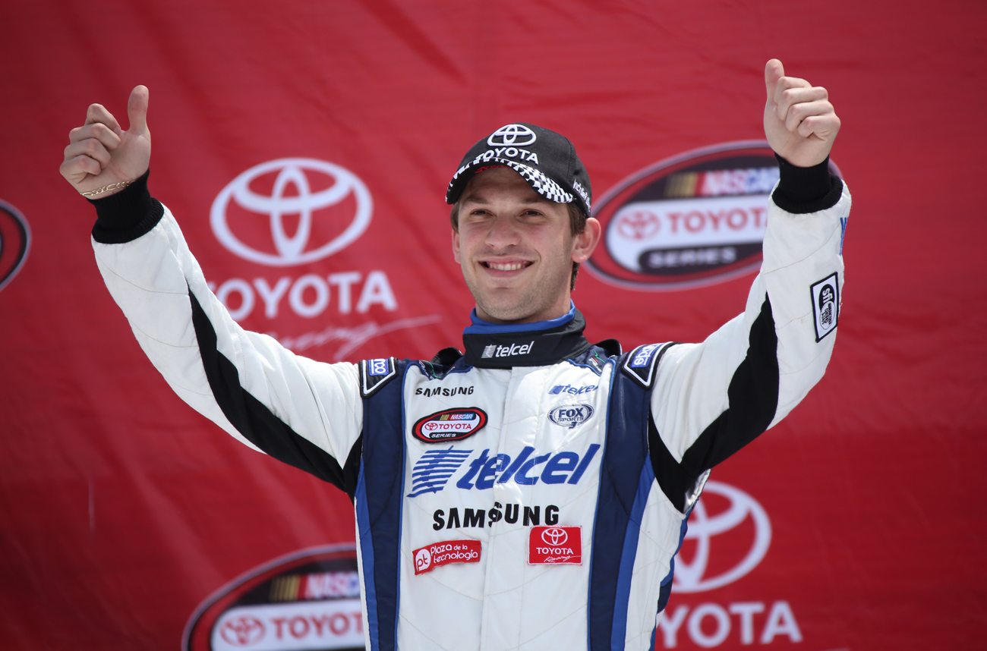
Media Relations & Strategic Communications Plan
Georgetown PRCC Capstone 2015

ACKNOWLEDGEMENTS

To the Multicultural Development Department at NASCAR:

You provided me with the opportunity to grow as a student through the NASCAR Diversity Internship Program, but such an invaluable experience lit an even bigger fire in me. Your passion gives me the strength to continue a career in diversity and inclusion to invest in future leaders, of all backgrounds. You truly are changing lives and you have several admirers that appreciate the work that you’re doing, including me. Thank you for allowing me to work with you.

To my family:

From Greece to Australia, Los Angeles to Washington D.C., your support and nourishment have traveled with me as I continue to fulfill my dreams. Yet, it is the strength, integrity and courage that you all instilled that allowed me to define my own path and be fearless. Dad, Mom, Lloyd Jr. and Schin, this milestone is celebrated by all of us, and together, we will continue to serve the Kerr and Whitfield name proud.

Table of Contents

Executive Summary 4
Background 6
Situation Analysis 25
Opportunity Statement 25
Goal 26
Objectives 26
Key Publics 28
Brand Positioning and Framing 36
Messaging 38
Strategies and Tactics 41
Calendar 50
Budget 54
Evaluation and Measurement 58
Conclusion 65
Appendix 66
Creative Materials 67
SWOT Analysis 80
Primary Research and Interviews 81
References 91

Executive Summary
Since their first race in 1948, NASCAR has grown to be one of the most recognized professional sports in the United States and a premier sport for fortune 500 business partnerships. Some of the most legendary racers have emerged from the sport, with classic household names such as Dale Earnhardt Sr., Richard Petty, and Jeff Gordon. Now, NASCAR is entering a new era of young and talented racers that are introducing a fun and exciting style of racing. Off the track, units such as NASCAR Green, an initiative to be more environmentally conscious, and the NASCAR Foundation, NASCAR’s non-profit arm, continues to help increase community growth and sustainability. In 2000, NASCAR Diversity was introduced to create opportunities for women and people of color, on and off the track, to become more connected with the sport and help cultivate a stronger organization.
NASCAR Diversity is one of the top organizational initiatives at NASCAR. However, several years and five diversity programs later, NASCAR Diversity lacks the visibility it needs to maximize its full potential and most are unaware that such programs exist. Additionally, there is a negative perception of NASCAR that often gets more attention, overshadowing NASCAR Diversity, and taking away from the public’s exposure to their inclusive efforts. If NASCAR Diversity does not increase awareness of their brand, they could see challenges with potential corporate partnerships, continued misperception of the organization, and decreased participation in their programs.
The solution to this challenge is to raise brand awareness of NASCAR Diversity and gain a better understanding of their brand story and brand message. The author plans to create a platform for NASCAR Diversity to tell their story, connect with influencers, engage stakeholders and establish them as a leader in the diversity and inclusion space within professional sports. NASCAR Diversity has built a foundation and a pipeline to diversify their organization through programs such as the NASCAR Diversity Internship Program and NASCAR Drive for Diversity Program, which showcases the commitment and value they feel helps create a more competitive organization. Compared to other professional sports such as National Basketball Association, the National Football League and Major League Baseball for example, NASCAR Diversity has the opportunity to establish a unique presence in the diversity and inclusion space throughout professional sports and identify why their brand should be a leader in the space.
The author is extremely excited to present a strategic communications plan to help NASCAR Diversity in building brand visibility. The strategies include raising awareness, leveraging partners, brand advocates and influencers, educating key publics, highlighting program alumni, and strengthening the overall NASCAR Diversity community. NASCAR Diversity has the opportunity to take a definitive stance to establish why diversity and inclusion is important to them. This plan helps implement effective and efficient tools to provide a concrete platform of brand messaging, build awareness and improve the visibility of the diversity programs. Through identified key publics, this plan will help NASCAR Diversity not only raise awareness but assert themselves in the professional sports industry as a leader in diversity and inclusion.
The projected cost of this plan is $126,133.88-140,058.88, in addition to professional fees. Implementation should begin immediately as parts of this plan should be executed at the start of the 2016 race season, which starts in February 2016. It would be an honor and a privilege to assist NASCAR Diversity in the successful implementation of this plan, and raise awareness of their commitment to strengthening the NASCAR organization.

BACKGROUND
Background

EXTERNAL ENVIRONEMNT
Corporate social responsibility (CSR) and diversity and inclusion in professional sports

Corporate social responsibility (CSR) refers to a business practice that involves participating in initiatives that benefit society. CSR is becoming more "mainstream" as forward-thinking companies embed sustainability into the core of their business operations to create shared value for business and society. Socially conscious consumers express a general preference for companies making a positive difference in the world.” In fact, according to Nielsen, these were the results when speaking to consumers of all types:
- 62 percent prefer to work for these (CSR) companies
- 59 percent invest in these companies
- 46 percent say they will pay extra for products and services from these companies

In an article on CSR and sports, sustainability expert Neill Duffy said this about professional sports franchises, “We need big solutions (in reference to CSR) to address these big issues and I believe major sports events have a big role to play, and can play a much more significant role than they have to date. I’m talking about teams embracing sustainability at the core of their DNA using the power of their engagement platforms to inspire millions of people to do the same.” This is powerful because it’s exploring how sports organizations can become better businesses through this sustainability-led model.
Under the CSR umbrella, there is diversity and inclusion. The industry standard definitions of diversity and inclusion are as follows:
- Diversity is the collective mixture of our human and organizational assets characterized by our similarities and differences.
- Inclusion is leveraging the power of diversity in a respectful environment that encourages all to participate and contribute to further the organizational mission.
Therefore, diversity is the ultimate goal for organizations to attain and inclusion is the pathway to get there.
From Hollywood to Fortune 500 companies to professional sports leagues, diversity is a major challenge for various industries to overcome. Several reasons create hurdles for diverse growth, such as socio-economic backgrounds, educational barriers, or geographical locations; these are just some of the barriers many groups, especially people of color have dealt with, and the inability to maximize opportunities to better their future. Throughout professional sports leagues in the U.S., diversity and inclusion has become a standard platform to be more socially responsible, inclusive and sensitive toward social justice issues. Some common themes to develop pathways of inclusion include: supplier diversity (working with business that are women and minority-owned), CEOs direct involvement, technology as a diversity tool, affinity (or resource) groups, and flexible work environment.
Many of the U.S. sports leagues, or the so-called “stick and ball sports,” the NBA, the NFL, and the MLB for example, do important work in their local communities and raise hundreds of millions of dollars in the process for charities and causes that they support, which tend to be very locally relevant to the organizations concerned. Leagues are holding themselves accountable for diverse hiring practices, diversity initiatives to engage fans of all backgrounds, and to increase the number of women in the front offices of primarily male-dominated organizations.
In a primary research survey, when asked what role do professional sports play in social justice issues, respondents revealed the following:
- “They are a major influence on society as a whole. They impact the whole nation.”
- “While the sport itself is the main business initiative, leagues have a social responsibility not to support, enable or promote behavior, actions that are counterproductive to improving social justice issues such as race relations and diversity.”
- “Pro sports have an impact on race relations similar to music and mathematics, sports have a universal appeal that is appreciated by all people worldwide. There is more work to do to reach higher inclusiveness.”

The importance of these reflections show how the reach of professional sports transcend beyond just a sports fan; leagues have a wide range of attention and visibility, making it imperative to use their platforms to positively engage their communities. One major tool to measure success of inclusion in professional sports leagues includes the Institute of Diversity and Ethics in Sports (TIDES). Directed by the renowned Dr. Richard Lapchick, TIDES measures the success of diversity and inclusion in professional sports through a yearly report card (The Racial and Gender Report Card or RGRC). The NBA, the NFL, the WNBA, and the MLB are annual participants in this report card and have made real progress in their efforts such as better hiring practices and youth development. Leagues such as the National Hockey League (NHL) and the National Association for Stock Car Auto Racing, Inc. (NASCAR) do not participate; although, NASCAR works closely with Dr. Lapchick as a personal consult on this topic.
Diversity and inclusion can promote increased engagement if an organization employs a holistic, strategic approach.

- Diversity & Inclusion Representative at the U.S. Tennis Association

Where many leagues have reached an acknowledgeable level of diversity among the playing field, court, or arena, there is still a long-way to go for leagues such as NASCAR, who are not where they want to be, but working aggressively to make a change. When asked do you think the motorsports industry does a good job of presenting themselves as an open and inclusive industry, the author’s research survey concluded that 42 percent of respondents said “no, not at all“; while 25 percent said “no, but they are getting better.” A follow up question lists reasons why, including lack of diversity and community initiatives; however, nearly 60 percent said, “Because I rarely or never hear about their inclusive efforts in the news or media.” As leagues continue to uncover the “milestone moments” and break down barriers of inclusion, such as the NFL hiring the first female coach in 2015, their needs to be more engagement with the day-to-day events that are connecting these sports and their diverse audiences to tell their story and raise brand awareness of inclusion.

INDUSTRY:
NASCAR

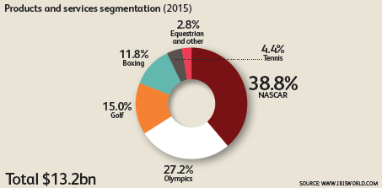
The National Association for Stock Car Auto Racing, Inc. (NASCAR) is the sanctioning body for the number one form of motorsports in the United States. NASCAR consists of three national series (the NASCAR Sprint Cup Series, NASCAR XFINITY Series, and NASCAR Camping World Truck Series), four regional series, one local grassroots series and three international series. They generate an estimated 38.8% of the racing industry’s revenue, which includes Indy Car Racing and Formula One, and is on pace to earn an estimated $5 billion in 2015. NASCAR’s fan base today was built on generations of loyal race fans and families, which stems from the head of the organization itself, in the France family. NASCAR is family-owned and started in 1947 by Bill France Sr.. By the 1980s, Bill France Jr. took over as Chairman and CEO and in the early 2000s, Bill Jr.’s son, Brian France, became the Chairman and CEO of NASCAR as we see it today. Other NASCAR industry leaders from the France family include Lesa Kennedy France (Brian’s sister), Jim France (Bill Jr.’s brother) and Betty Jane France (Bill Jr.’s widow).
As one of the oldest professional sports in America, NASCAR began as a mostly southern sport, rich in American tradition, family, religion, and the best racers in the country. As NASCAR evolved, it became a premier league for major advertisement, entitlement sponsors such as current sponsors Sprint and Xfinity, and partnership opportunities. The visibility that NASCAR offers to major businesses, sponsors, original equipment manufacturers (OEM), and others, helped catapult the sport as a major marketing and business investment for companies. Yet, in the mid-2000s, they took a turn for the worst. TV viewership was down 21percent from its 2005 highs, and ad spending fell by 16 percent in a time when the value of live TV properties was beginning to surge. Live race attendance crashed and tracks were forced to slash ticket prices, even for major draws such as the Daytona 500 (which is NASCAR’s Super Bowl). However, after the recession, NASCAR and race teams clawed their way out of the devastation. Despite falling viewership, NASCAR was able to pick up ten-year TV rights deals with both NBC and Fox, worth a combined $8.2 billion in 2014. Additionally, NASCAR also picked up another ten-year deal with Comcast Xfinity, which is now the naming rights partner of NASCAR’s second-tier series, reportedly worth an average $20 million per year.
Throughout the last few decades, more sustainability-led initiatives have developed within NASCAR’s business model. However, from a social awareness standpoint, they are plagued by their misperception of not being socially responsible and a diverse organization. Sponsors and partners show dubious signs of NASCAR’s social progression in an era of consumers that are extremely socially aware and active. In April of 2015, GoDaddy ended their sponsorship of race car driver Danica Patrick, stating: “NASCAR has been a tremendous domestic platform to help us achieve an 81 percent aided brand awareness domestically, but at this stage, we need a range of marketing assets that reach a more globally-diverse set of customers,” GoDaddy chief marketing officer Phil Bienert said in a news release. This is just one example of a major sponsor voicing their concerns of NASCAR’s need to evolve their brand in more modern times.
To build sustainability, NASCAR’s top priority, other than safety and innovation, has been diversity and inclusion. In the last two decades, diversity in NASCAR has become a major business objective to grow the sport, combat negative images, and misperceptions of being a non-diverse sport. Currently, one in five NASCAR fans is multicultural, as NASCAR has five ongoing diversity initiatives to increase brand awareness and develop inclusive pipelines.
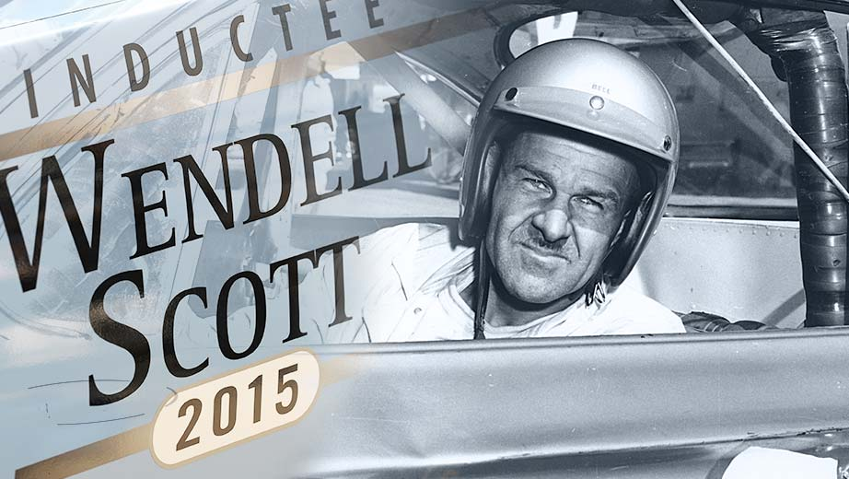
In 2015, NASCAR inducted Wendell Scott, the first African-American driver for a premier race circuit and first person of color, into the prestigious NASCAR Hall of Fame. Mr. Scott was the first African-American to compete full-time in NASCAR’s premier race series and on December 1, 1963 at Speedway Park in Jacksonville, Florida, he became the first African-American to win a NASCAR premier series event. It was a great opportunity to honor Scott’s family for the obstacles Wendell overcame during an era that was heavily influenced by the civil rights movement. This was a significant moment for NASCAR and it is important to build on this recognition of a decorated hero within NASCAR’s history. The media response was overwhelmingly positive and perhaps they should consider additional ways to honor Wendell Scott’s memory and his impact on the sport, as NASCAR continues to combat diversity challenges.

Obstacles to overcome
Due to their historically southern roots, many consumers feel as though NASCAR’s inclusive efforts could be better and that they have not evolved the sport to reflect the diversity of our country. For example, earlier this year, after the Charleston, SC church shooting, South Carolina governor, Nikki Haley, called for the removal of the Confederate flag from the state’s capitol. As the conversation moved forward, sports journalists began calling out NASCAR to ban the presence of the flag from its races. NASCAR, as of July 2015, has an official policy in which it requests that fans and partners “refrain from displaying the Confederate Flag at NASCAR facilities and events.” The organization realizes that the flag is considered an offensive symbol and stands against its values of fan diversity.
However, there was never an official ban of the flag, even though racetracks reside on privately-owned property. NASCAR racetracks took a stand as Daytona International Speedway and 29 other tracks asked fans to stow their rebel banners during the weekend’s race on the Fourth of July — its first race since the tragic incident — announcing an exchange program for fans who wanted to swap out the Confederate flag for an American one. Race car drivers and legends Jeff Gordon and Dale Earnhardt Jr. supported the cause. Unfortunately, at this Fourth of July Coke 400 race in Daytona Beach, the number of Confederate flags flown by loyal race fans seemed to increase substantially that race weekend. “It’s just a Southern pride thing,” Larry R. from Jacksonville Beach, Fla., told the AP. “It’s nothing racist or anything. This isn’t a Confederate thing so much as it is a NASCAR thing,” he added. “That’s why I fly it.” This fan and many others were quoted saying similar comments, assuring the press that it represented Southern pride, and was not meant to have a racist connotation. This is significant, not only because of the negative perception that suggests NASCAR needs to take a stronger stance on issues of this magnitude, but they also need to consider ways to educate race fans on the organization’s rationale to diversify: to be a better, stronger sport. Raising awareness and visibility of NASCAR’s positive efforts to combat this type of social irresponsibility needs to increase. The public needs to see a real effort to make a difference and stand strong to their commitments to include members of all backgrounds.
In an October 2015 interview, Brian France voiced his mission to make the sport more inclusive. In response to the recent ban of the Confederate flag in South Carolina, distancing NASCAR from the Confederate flag is part of a bigger vision for inclusion in motor sports held by France and NASCAR. "We want everyone in this country to be a NASCAR fan. To do that, you have to break down some barriers. We've always been offensive minded about this, not only because it's the right thing to do, but the best thing we can do to make NASCAR bigger and better," France said.
“Perception is not reality,” said Mike Helton, President of NASCAR when asked about the biggest challenges NASCAR faces with diversity. The misperception of NASCAR being a southern, majority Caucasian-American, and religious-based organization still resonates with certain demographics. NASCAR is diligent in their efforts to eradicate this perception and cultivate an environment where all fans feel inclusive, yet, individuals can’t engage with programs or initiatives that they don’t know exists. Increasing the visibility of their efforts will inevitably begin to shift the mindset of those that distance themselves from actively supporting the sport, as well as educating current fans that don’t understand the full benefit of diversification.
Most recently, the Minority Youth Matters Movement (MYMM) initiated plans to protest NASCAR and its sponsors at 30 locations around the country, including the White House. The youth organization says it aims to demonstrate its "commitment to influence change in the diversity and inclusion practices at one of the nation's most renowned sports brands." Over the years, NASCAR’s reputation of being a non-diverse sport has elevated to a point where things need to change; and they have changed, but there’s more to be done. It is vital that audiences can visibly see that NASCAR has a very aggressive plan in place to increase pathways of inclusion, change the misperception, and has established efforts to diversify.

NASCAR Media Channels
NASCAR produces several owned media channels, including its own wire service, NASCAR.com news site, NASCAR Illustrated Magazine and several digital and social channels to highlight every race series and business unit throughout the organization. However, it is rare that you see NASCAR mention diversity news and updates on these channels, as they focus more on the at-track events. There is an opportunity to present more diversity news and highlights to build brand awareness and display a more cohesive representation of inclusive efforts.

CLIENT:
NASCAR Diversity

NASCAR Diversity is operated by the multicultural development department at NASCAR’s headquarters in Daytona Beach, FL. Run by the Director of Multicultural Development, Dawn Lewis, the department has significantly impacted NASCAR’s position as an inclusive professional sport and business; impacts include establishing a racing pipeline for minorities and women of color, engaging with young professionals looking to advance their careers as well as scholarship opportunities, and initiating a grassroots program to build relationships in diverse communities near racetrack locations.
Their mission statement states: to engage women and people of diverse, ethnic, and racial backgrounds in all facets of the NASCAR industry.

NASCAR Diversity’s objective is to engage industry stakeholders in efforts to broaden the audience of the sport, increase minority and female on track participation, introduce career opportunities in the motorsports industry, and network with multicultural target markets. NASCAR Diversity has established several programs to not only engage the next generation of potential race car drivers, but to engage with the next generation of business leaders, engineers, marketers, lawyers, scientists, community activists and other prominent professions. NASCAR Diversity enables NASCAR to expand beyond the motorsports industry and expose millennials, young professionals, sports fans and others of all backgrounds to an unique opportunity to make the sport better.
Given the historical perception, NASCAR Diversity is the key to changing public perception of NASCAR and a business imperative to build sustainability, and a community of innovation and creativity. One method of maintaining the long-term objectives for NASCAR Diversity is leveraging major influencers, such as Max Siegal, a former sports and entertainment lawyer who founded Revolution Racing (Rev Racing) and NASCAR’s Drive for Diversity program. Another is Alba Colon, the first woman and Latina to be the lead engineer for Chevrolet Racing. Industry players such as Mr. Siegal and Ms. Colon have the innovation, visibility, and voice to reach key stakeholders, such as brand advocates and target audiences, to continue to cultivate a community of inclusion and a competitive business platform.
Additionally, key case studies for NASCAR Diversity can continue to grow their efforts, share their story and help to establish unique partnerships. One example includes NASCAR Diversity’s piloted program with the University of Southern California (USC) Viterbi School of Engineering and Toyota’s research and engineering facility to offer top engineer students the chance to visit Toyota’s facilities and learn how to apply classroom tools in real world situations. This type of storytelling has a major impact for NASCAR Diversity because it speaks of the community relationships established, highlights their major partner in Toyota, and captures the opportunities and investment of young leaders in our country. It is important for NASCAR Diversity to continue efforts like this and to raise awareness of their interest to create opportunities for women and people of color, because it makes them a better organization.

PRODUCTS/SERVICES/INITIATIVES
Drive for Diversity & Drive for Diversity Pit Crew Development Program
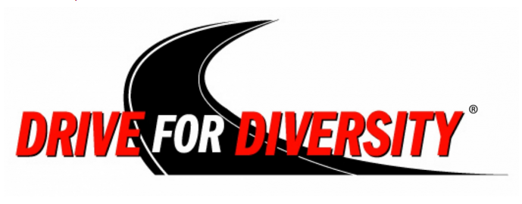
The NASCAR Drive for Diversity (D4D) program initiated in 2009 in an effort to bring women and people of color together, to compete in on the track circuits throughout NASCAR. The notable drivers and alumni of the program include: Darrell “Bubba” Wallace of NASCAR Xfinity, the first African-American to win a primer series race since Wendell Scott in 1963; Daniel Suarez of NASCAR Xfinity, originally from Mexico and a major star on the rise recently winning rookie of the year for the Xfinity series; and Kyle Larson of NASCAR Sprint Cup, the first Japanese-American to race at the national level and the Sunoco Rookie of the Year in 2014. In the author’s primary research survey, when asked have you heard of the above athletes in NASCAR’s top circuits, more than 70 percent of respondents, who were avid sports fans, never heard of the drivers. However, this program is NASCAR Diversity’s most successful program and the increased pipeline of diverse drivers has showed true promise. Additionally, the pit crew development program has proved to be as successful, with a 100 percent placement rate, with alumni such as Richie Williams of Roush Fenway Racing. Also, a top pit crew brand ambassador includes Dion “Rocko Slaw” Williams of Hendrick Motorsports, Hendrick being the top race team (worth $350 million) within the NASCAR circuit.

NASCAR Diversity Internship Program (NDIP)
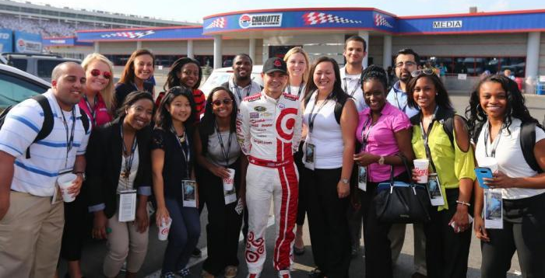
The NASCAR Diversity Internship Program (NDIP) identifies and engages top student talent across the country’s best colleges and universities. In past years, NDIP has had an intern- to-hire placement rate (of those students who graduated and were eligible to work full-time) of 60 percent in 2013 and 100 percent in 2014 to work for NASCAR or throughout industry. In 2015, six NDIP interns were hired by industry partners. NDIP offers 20-30 students the opportunity to work at NASCAR or one of its partners, for a 10-week program during the summer. Last year, they had more than 400 applicants. Using alumni and university networks, NASCAR Diversity hopes to increase this number in subsequent years based on the outstanding performance from selected students. Because of the success of the USC and Toyota pilot program, Toyota has agreed to add five additional internships for applicants of the NDIP program in 2016. Additionally, this program has the capability to reach the most influential group to grow NASCAR’s diverse following in millennials and sports fans.
Class of 2015

NASCAR Opinion Leaders Initiative
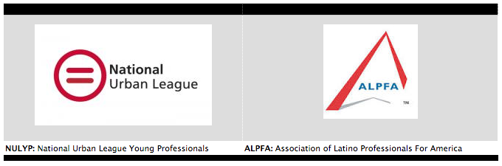
Established in 2007, the NASCAR Opinion Leader Initiative (NOLI) builds greater awareness, participation, and support of NASCAR in key race markets by connecting with diverse businesses, civic organizations, and community leaders. Additionally, NOLI serves as a forum to highlight and promote NASCAR’s other diversity programs (e.g. D4D, NDIP). NOLI currently has 10 activation cities throughout the race season, hosting small groups of 35-50 participants. NASCAR Diversity is looking to expand these activations to increase awareness and participation rates, build sustainable partnerships and brand advocates. With major partners such as the National Urban League for Young Professionals (NULYP), the Society of Hispanic Professional Engineers (SHPE) and the Association for Latino Professionals of America (ALPHA), NOLI has cultivated a grassroots pipeline for NASCAR Diversity to engage with local businesses and expand their community relations’ efforts. NASCAR’s top ten target multicultural markets include: Atlanta, Baltimore, Chicago, Dallas, Las Vegas, Los Angeles, Miami, Richmond, VA, San Francisco, and Washington D.C. Since this initiative is crucial to the growth of NASCAR Diversity, NOLI is looking to initiate a collegiate component to this grassroots engagement, especially with university systems in NASCAR’s key markets previously mentioned.

NASCAR Diversity Awards
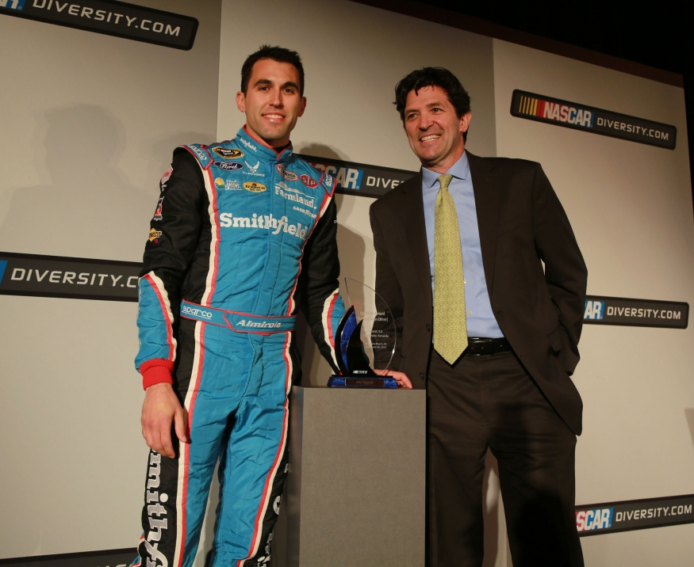
NASCAR Diversity Awards is the leading means to identify accomplishments in diversity and inclusion throughout the motorsports industry. The awards serve as a platform to highlight, promote, and strengthen relationships with industry leaders in the diversity and inclusion space. The award categories presented include exceptional drivers, crewmembers, interns, organizations, institutions, and partners who have demonstrated leadership in the sport.

NASCAR Diversity Scholarship Program
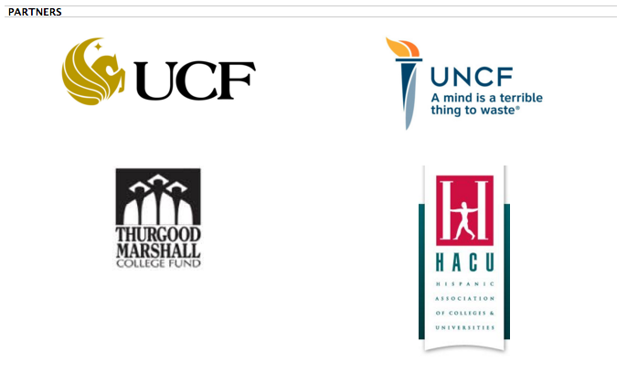
NASCAR Diversity and its partners provide funding for scholarships to institutions of higher education to Historically Black Colleges and Universities (HBCUs) and Hispanic Serving Institutions (HSI) to nurture diverse talent and raise sports visibility. Contributions are made to the following partners: the United Negro College Fund, the Hispanic Association of College & Universities and the Devos Sports Business Management Program at the University of Central Florida (which produces the TIDES report card mentioned previously). Most recently, NASCAR Diversity worked with Chevrolet, another major diversity partner, during Hispanic Heritage month to offer three scholarships to STEM students.

PROMOTIONS/NASCAR DIVERSITY SOCIAL AND DIGITAL CHANNELS

Currently, NASCAR Diversity has two channels of engagement: the official NASCAR Diversity Website and the official Twitter page of NASCAR Diversity (@NASCARDiversity).

Website
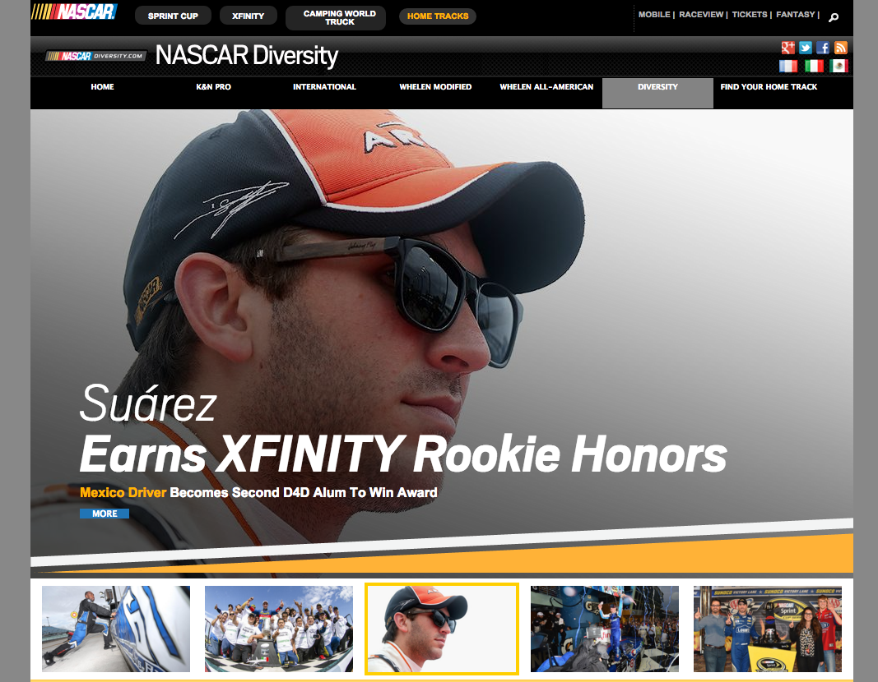
The official NASCAR Diversity website is the landing page for news and updates on NASCAR Diversity programs. The site provides an overview of all the diversity programs and links to partners of the department. It houses news releases, videos, applications for programs, and a news archive section. This would also be a great platform for case studies, highlighting corporate partners and a section for NASCAR Diversity-specific social media channels.

Twitter
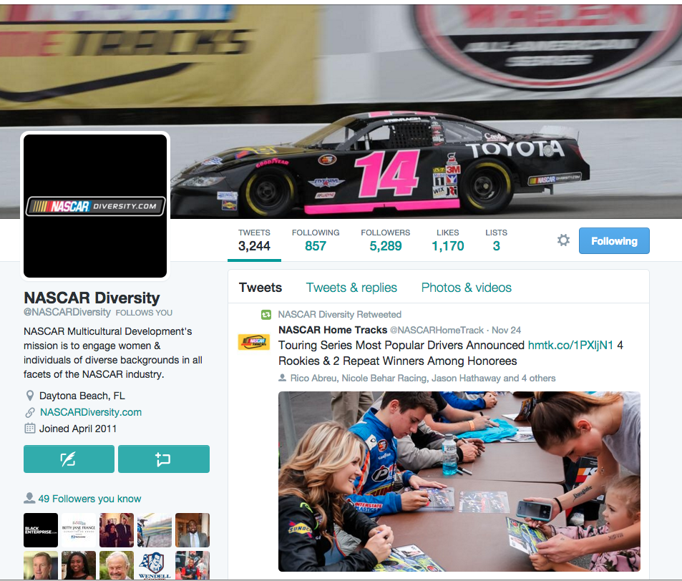
Their Twitter page has nearly 5,300 followers, is very active and engages with community partners ALPHA and NULYP frequently. However, this is their only form of social communication with stakeholders outside of their website. Additionally, the main NASCAR handle (@NASCAR) has more than 2 million followers, and rarely posts content focused on diversity initiatives. NASCAR Diversity should consider other platforms to engage stakeholders and target audience to drive traffic to their website, to NASCAR’s main communication channels as well as providing platforms for stakeholders to follow, recieve news and updates, and engagement with influencers, such as Chevy and Toyota.
In addition, earned media has been a challenge for NASCAR Diversity. They are competing internally with other NASCAR units to gain visibility in the media (e.g. races, sponsors, etc.), both with NASCAR’s owned channels and external media (e.g. NY Times, USA Today, etc.). There is an opportunity to tell NASCAR Diversity’s story in a compelling way to gain visibility and awareness on owned social and digital platforms, as well as establish their own presence externally through earned media.

Messaging
The main spokespeople that provide commentary on NASCAR Diversity’s progress, include: Steve O’Donnell, executive vice president and chief racing development officer, Jim Cassidy, vice president of racing operations, and Paula Miller, vice president and chief human resources officer of NASCAR.
When discussing NASCAR Diversity, a recurring talking point includes, “One in five NASCAR fans is multicultural.” This messaging is used quite frequently but doesn’t reveal what “multicultural” means as far as their reach to different ethnic segments to be more inclusive. Another talking point includes, “we are not where we want to be, we are the first to admit that”; this message has been used since 2004 and is still used today. Other recurring messages when referring to NASCAR’s diversity and inclusion practices, say NASCAR wants to be diverse because “it not only makes business sense, but it’s the right thing to do”; as well as, we want “NASCAR to reflect the fabric of America.” It is important to consider a refresh of messaging as NASCAR Diversity continues to build on the foundation they started 15 years ago. They are not where they want to be, but they are far from where they were. Additionally, movements such as the Millennial Youth Matters Movement and the Confederate flag debacle may have accumulated less traction if NASCAR Diversity’s visibility was stronger and their messaging promoted a stronger stance, rather than a request.

MARKET SHARE

NASCAR Diversity’s share of voice in the “diversity in professional sports” media space is minimal. No one particular league has dominated the professional sports “diversity and inclusion market,” per say, in recent years, but sports audiences are aware of the inclusion efforts on behalf of certain leagues within professional sports (see competitors section). In the author’s primary research survey on the public’s interest and awareness of diversity in professional sports, here are some key findings:
- When asked about a leagues support of social justice issues, a third of respondents said that they were “just sports fans” and support of diversity issues would not increase their engagement.
- Participants ranked NASCAR as the least inclusive of all the major leagues (including NBA, NFL, NHL, MLB, MLS, and WNBA) and the top reason why included lack of presence in the news or media and lack of diverse athletes.
- 52 percent of respondents when asked about NASCAR’s diversity initiatives said they did not know their programs existed, but were interested in learning more.
- Lastly, when asked how NASCAR Diversity can better engage with diverse groups, 60 percent of respondents said better media coverage.
There is a tremendous opportunity to increase NASCAR Diversity’s share of voice in a marketplace currently unoccupied by one main league.

COMPETITORS

National Basketball Association (NBA)
- Initiatives:
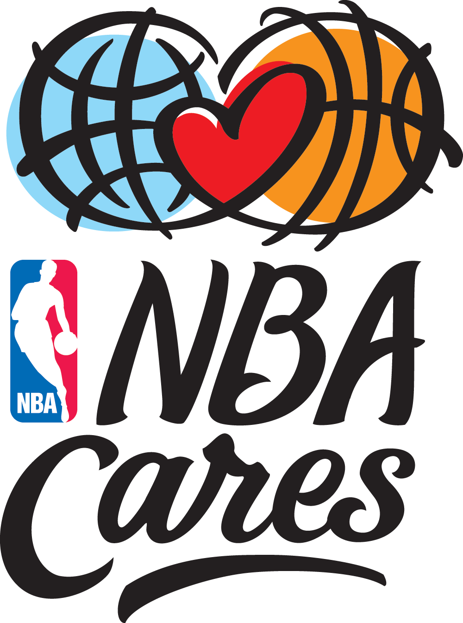
  - NBA Cares is the league's social responsibility initiative that builds on the NBA's long tradition of addressing important social issues in the United States and around the world. Through this umbrella program, the NBA, its teams and players have donated more than $105 million to charity.
  - NBA Fit (w/ WNBA) – A league wide effort to increase physical activity and overall health of youth.
- Social presence
  - NBA Cares has a strong social and digital presence, with strong followings on various platforms, showing the commitment the NBA has to engage outside of basketball.
- How NASCAR Compares
  - NASCAR’s community initiative, NOLI, isn’t as robust and established as NBA Cares, which has flourished into an entire CSR platform of projects. An additional opportunity to engage lies in health and physical activity, where NASCAR doesn’t have an industry presence.
  - Compared to the NBA, who reaches an average of 150,000 followers on all their social channels for NBA Cares, NASCAR Diversity should focus more on a stronger social presence to reach desired audiences (young sports fans, millennials, etc.), as their only channel of engagement is their Twitter handle of 5,200+ followers.
National Football League (NFL)
- Initiatives
  - Hometown Huddle – Community engagement, provided by each team, connecting with the local communities, youth and schools.
  - Play 60 – NFL’s initiative to get youth up and moving, providing a forum for physical activity and health awareness.
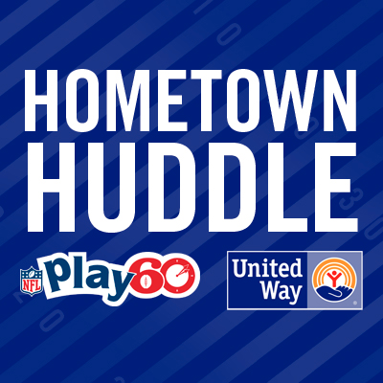
  - NFL Business Connect Program/Consumer Product Program – NFL’s initiative to support supplier diversity and patron more women and minority-owned business.
  - One World – NFL’s scholastic, education program to teach youth about diversity in the classroom.
- Social Presence
  - The NFL lacks a major social presence to support each of the top initiatives. They have one Twitter handle to support Play 60. However, the main NFL handle, @NFL, has more than 14 million followers and posts CSR initiatives frequently.
- How NASCAR Compares
  - NASCAR’s NOLI program is comparable to the NFL’s Hometown Huddle initiative. NASCAR could use the Hometown Huddle program as an example of how to increase relationships with different racetracks to establish a stronger community presence.
  - NASCAR Diversity lacks a supplier diversity pipeline, which would engage minority and women-owned businesses, as well as educational programs.
  - Socially, both leagues are lacking in social channels to support individual programs.
Major League Baseball (MLB)
- Initiatives
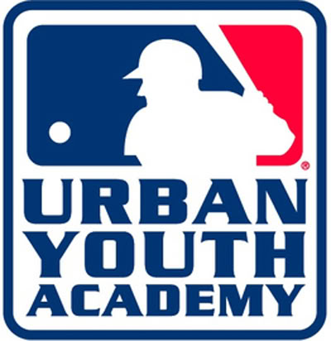
  - Reviving Baseball in Inner Cities & MLB’s Urban Youth Academy – Youth development programs to connect with metropolitan, city areas where youth may not have access to organized baseball programs.
  - Commissioner’s On-Field Diversity Task Force – A task force of advisors to help the MLB increase diversity and inclusion efforts. Members include industry influencers, community leaders, and partners.
  - Major League Baseball Diversity Business Summit/Diversity Economic Impact Engagement Initiative (DEIE)/Major League Baseball’s Diverse Business Partner’s Program – All these programs are focused on supplier diversity and increasing partnerships with women and minority-owned businesses.
- Social Presence
  - The MLB has platforms set up and a respectable number of followers, but is not very engaged and consistent with postings.
- How NASCAR Compares
  - NASCAR’s Drive for Diversity program serves as a teaching platform comparable to the MLB’s youth development programs.
  - However, supplier diversity is another pathway that NASCAR Diversity has yet to establish.
  - NASCAR Diversity does not have as many social channels to support the previously mentioned programs as the MLB, but their engagement on one channel outweighs multiple, non-active handles.
National Hockey League (NHL)
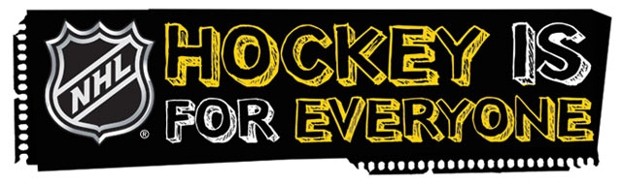
- Initiatives
  - Hockey is for Everyone (HIFE) – NHL Diversity’s initiative to get young athletes from all backgrounds to learn the fundamentals of hockey.
  - Future Goals (academic inclusion) – a STEM focused program to help teach students about science, technology, engineering and math through hockey.
- Social Presence
  - The NHL’s diversity social media presence is non-existent.
- How NASCAR Compares
  - NASCAR has more programs in place that stem outside of the racetrack.
  - However, just like the NFL, the NHL has a scholastic program dedicated to improve unique skills and diversity, an area NASCAR could consider.
  - NASCAR Diversity’s social engagement outweighs the NHL.
RESOURCES

NASCAR Diversity is run by the multicultural development department at NASCAR, currently consisting of three people. The department is headquartered in Daytona Beach, FL. This department is funded by NASCAR and partners Chevrolet and Toyota. In the last year, they lost a partner in Coca-Cola, which is a big focus for the group to fill that partnership void during the next season (2016).
NASCAR Diversity hosts a Drive for Diversity Combine every year in October, which is a major event to increase awareness and participation for their on the track experience. This is the number one annual event for the department, because of its success rate and alignment with NASCAR’s business model to develop the best racers throughout the sport. Many influencers in the industry follow or attend this event, and the combine often garners tremendous amount of coverage to highlight the program, upcoming drivers and the industry’s efforts to develop an inclusion pipeline. NASCAR Diversity is also a part of NASCAR’s industry action plan, helping to build next generation fans, digital and social media presence, and expand their event experience.

Situation Analysis, Opportunity Statement, Goal & Objectives
Situation Analysis

Where are they now?
NASCAR Diversity is at a critical point because external challenges such as the Confederate flag backlash and the Minority Youth Matters Movement are overshadowing the visibility and brand awareness of their inclusion efforts. Simultaneously, a major challenge for NASCAR Diversity is gaining visibility for their programs among an environment of misperception, the visibility of other organizational events (races, partners, etc) and other leagues’ diversity initiatives, which are well-known and most are digitally established. Despite these factors, NASCAR Diversity has come a long way to cultivate an inclusive organization and should be recognized as an authentic leader in the diversity and inclusion space, both within motorsports and in the greater sports realm.

What could get in the way of success?
The potential roadblocks that could get in the way if NASCAR Diversity doesn’t increase their visibility, includes partnership challenges, continued misperception of inclusion, and a decrease in program participation. Their compelling story of the community they’ve developed will continue to go unheard, their relevance in the marketplace will be unsustainable and their programs could suffer, all of which does not reflect well to key partners.

Opportunity Statement

There is an opportunity for NASCAR Diversity to define what diversity and inclusion means to the organization at large and showcase that positioning to increase visibility, expand their brand awareness, and develop a platform for their brand story. If these challenges are not addressed, NASCAR Diversity could miss out on an opportunity to lead the “diversity in professional sports” marketplace by sending a strong message of inclusion.

Goal

Using effective media relations efforts, successfully increase awareness, participation, and the visibility of NASCAR Diversity through strategic engagement, internally and externally

Objectives

- Increase the number of participants in NOLI by two additional community groups per quarter and increase the number of applicants in NDIP by 50, by the end of 2016

- Build awareness of NASCAR Diversity on and off the track by achieving one to two top-tier print media placements per quarter, by the end of 2016 season

- Strengthen relationships with current corporate and community partners on social platforms by reaching 250,000 followers per quarter, by the end of 2016 season

- Expand awareness of NASCAR Diversity on at least two NASCAR-owned media channels by the end of 2016 season

- Enhance social presence by increasing Twitter following by 2,500 members by the end of 2016 season and establish additional social channels

The following target audiences will help reach the intended goal and effectively achieve the objectives of this plan. Below is a detailed description of key targets.
KEY PUBLICS
National millennial sports fans, 18-34,
Demographics
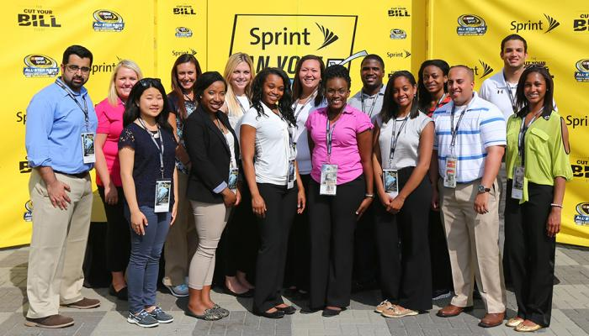
The millennial generation is more racially diverse than prior generations. About one in four millennials are non-white, and about one in five millennials are Hispanic. Additionally, millennials are on track to be the most educated generation in history. Therefore, the younger members of this group have tremendous influence in growing NDIP as well as increase scholarship participation. Similarly, the older members of this group will be key to growing NOLI activation markets and participation. They are looking to network and become a part of professional development groups; the same groups NOLI is looking to engage with such as NULYP.
The median household income of older millennials (25-34) is similar to that of the average household (about $52K). The median household income for younger millennials (<25) is about 34 percent lower than the average; this is because many are still in school, un- or underemployed, or just starting their careers. This group is putting off more serious life commitments to become more financially and geographically stable, as 64 percent of millennials have never been married. Therefore, targeting this group during their colligate experience can help increase the pipeline of young diverse leaders NASCAR is looking to cultivate through NDIP.
Psychographics
When seeking to engage with Millennials, the key is to understand what they expect and how their reaction will differ from previous generations. Millennials are savvy content consumers and require brands to tell stories, create share-worthy content, and foster an experience around a product/service. They expect transparency, desire relationships and authenticity; they are willing to set cynicism aside when a brand is trying to be sincere. If millennials don’t like you, they will ignore you; they desire a two-way conversation and actively choose what they view and when and how they view it.
Relationship to Client
Millennials are a major percentage of the socially conscious consumers mentioned early, accounting for 24.6 percent of the total U.S. population (79 million) and are highly engaged when it comes to brands social responsibility efforts. For NASCAR Diversity to continue to increase their relationship with this group and build a unique sense of brand loyalty, they need to be authentic and share their challenges as well as triumphs to bridge a trusted connection with millennials.
Communication Channels
As far as how millennials consume, they are online constantly. The vast majorities have gone online to accomplish common activities such as using search engines (94 percent) and shopping online (88 percent). Many millennials view the internet as a platform to engage with brands and learn about their products; some 69 percent have visited a brand’s website, 67 percent have liked/followed a brand on social media, and 66 percent have read reviews. Since Twitter is the only social platform millennials can engage in a two-way conversation with NASCAR Diversity at the moment, it is important to engage with this group where they reside. This will help attain the following objectives: build awareness, increase program participation and grow NASCAR Diversity’s social media presence.

NASCAR Fans,
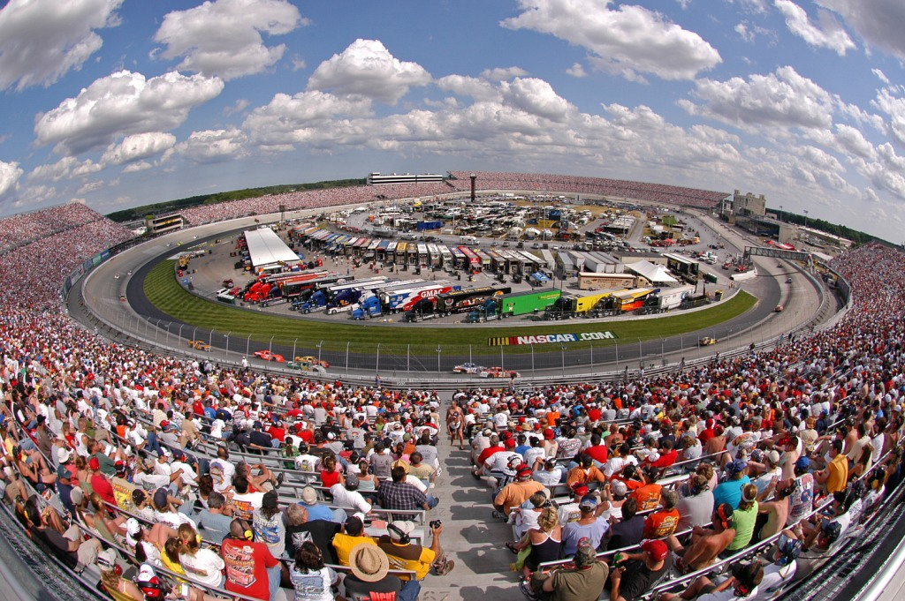
Demographics
In 2006, among voters who described themselves as NASCAR fans in Forbes’ Zogby Polls, 58 percent said they were conservative, 25 percent moderate, and only 12 percent liberal. This coincided with their partisan identification: only 20 percent called themselves Democrats, while 54 percent identified as Republican and 26 percent independent. Interestingly, back then 32 percent said they were making at least $100,000 a year and only 24 percent were making under $50,000. Well over half (57 percent) had a college degree. Additionally, 82 percent were Caucasian American, while just 7 percent each were Hispanic or African American.
By 2015, looking at a similar poll of NASCAR fans, Forbes found that the number of Democrats has doubled to 39 percent and the number of Republicans has declined to 36 percent — a 37 percentage point swing. One in three (33 percent) identified as liberal – almost triple that of 2006 – and the percentage of moderates has expanded by five points up to 30 percent. It is the number of conservatives that has shrunk down to 37 percent — a loss of 21 points.
What is so stunning now is the diversity of the sport’s fans – only 63 percent are Caucasian, while the percentage of Hispanics tripled to 22 percent and African Americans grew to 11 percent. Furthermore, the percentage of those earning less than $50,000 has swelled to 47 percent — about double that of 2006. Those earning over $100,000 are now down to 23 percent (from 32 percent). 43 percent of NASCAR fans in southern regions consume the sport compared to 23 percent in the Midwest, 20 percent in the west, and just 14 percent in the northeast. NASCAR Diversity has the opportunity to increase diversity segments in key markets in the west such as Los Angeles and Las Vegas, as well as the northeast, in the Dover, Pocono, and Richmond markets.
Psychographics
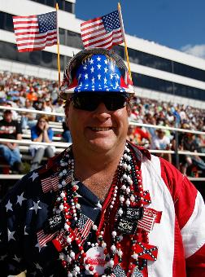
NASCAR fans are extremely patriotic, proud of their heritage as Americans and as NASCAR fans. Here is a fan comment surrounding NASCAR’s attempt at the flag exchange program mentioned previously: “Everybody else is getting to fly their flags in the United States of the America and have their heritage. Why can’t I have mine? That one was a Confederate battle flag right there, that wasn’t even a Southern flag.” Additionally, NASCAR fans are extremely proud of the southern tradition that reflects NASCAR’s beginnings, but some are hesitant to embrace the evolution of the sport to other popular, non-southern regions across North America.
Relationship to Client
NASCAR fans today stem from generations and families that have engaged with the sport for years. Many fans today have followed NASCAR for years as race families, such as the Earnhardts’, the Pettys’, and the Allisions’, have built legendary dynasties throughout the sports history. NASCAR fans are an extension of the NASCAR family as well as the biggest brand advocates for NASCAR and consumers often trust brands more when they know someone that advocates on the brands behalf. This group is instrumental in sharing the larger message on behalf of the organization and helping NASCAR Diversity reach their objective of building awareness, and enhancing their social media platform.
Communication Channels
The top sports websites among NASCAR fans include ESPN, NASCAR.com, NFL.com, YahooSports.com, and MLB.com. Of the nearly 40 million viewers last season, 77 percent viewed at least one race via television throughout the season. 44 percent of fans follow NASCAR on Facebook and 34 percent follow NASCAR on Twitter (2+ million followers for @NASCAR). Of the 11 million Facebook followers, at least 1.5 million engage with NASCAR at least 3 days a week. Of the 4.8 million Twitter followers (includes all NASCAR handles), at least 850K engage with NASCAR on a daily basis; additionally, up to 3.4 million engage on Twitter one to three times a week on Twitter. Given the different touch points and engagement platforms that NASCAR fans consume content, NASCAR Diversity has an opportunity to send a strong message and achieve the following objectives: increase social media presence and build awareness through NASCAR-owned media.

Colleges and universities
Demographics
20.2 million students are expected to attend American colleges and universities in the fall of 2015. An increasing number of African-American and Hispanic students are attending college. Between 2000 and 2013, the percentage of college students who were African-American rose from 11.7 to 14.7 percent and the percentage of students who were Hispanic rose 9.9 to 15.8 percent. Therefore, colleges and universities are becoming increasingly diverse and these diverse students are looking for opportunities to thrive.
Psychographics
Americans are attending college in record numbers, and it is increasingly seen as a requirement for young people, rather than an option. The increase in college attendance is impacting the lifestyles of young adults in a variety of ways, such as postponing marriage and childbirth, to seek education and training (mentioned in the millennial section above).
Relationship to Client
Colleges and universities are a primary resource for students to grow academically and gain professional experience through internship and fellowship programs. NASCAR Diversity Internship Program (NDIP) and scholarship programs offer college and graduate students the opportunity to gain tangible experience in business. The opportunity to build relationships with top universities allows NASCAR to establish a pipeline of talent to expand their workforce and business practices.
Communication Channels
Universities have their own networks, social channels, digital channels and campus associations that NASCAR Diversity can tap into and share their story to raise awareness. Additionally, there are several college-age publications such as U Magazine, College Life, Huffington Post College and university newspapers that can reach a wide university audience. This group helps NASCAR Diversity meet most of their objectives: build awareness, increase social media presence, engage partners, and increase program participation. There is also an opportunity to build the NOLI collegiate component that NASCAR Diversity is looking to establish, cultivating relationships with campus influencers, athletic departments and recruitment for other diversity programs such as NDIP and scholarships.

National advocacy groups, community partners and young professional organizations
Demographics
There are more than 42,000 businesses that are considered a civic, social, or youth-oriented organization. Although, the number of industry organizations have declined at an average annual rate of 0.9 percent in the past five years. Additionally, young adults have become increasingly less engaged in civic and social organizations. According to the Bureau of Labor Statistics (BLS), the unemployment rate for recent college graduates has remained higher than prerecession levels. This has caused many young adults to experience a delay in transitioning from adolescence to adulthood, specifically in launching careers, settling down in a community and starting a family.
Psychographics
National advocacy groups, community partners and young professional organizations provide the key audience that is mission-driven and cause-focused for the greater good. They are often looking to partner with larger organizations to increase their reach and broaden awareness of their issues. Vice versa, organizations in this industry gain a significant portion of their funding through donations and partnerships with corporations. When corporate profit increases, companies are more likely to partner with and contribute to organizations that promote civic and social interests. Additionally, technology and other entertainment outlets have been diverting participation away from the industry. Social media has increasingly allowed Americans to connect and communicate with likeminded communities without joining industry organizations, reducing demand.
Relationship to Client
With major partners such as the National Urban League for Young Professionals (NULYP), the Society of Hispanic Engineers (SHPE), and the Association for Latino Professional of America (ALPHA), this group is a natural audience to increase awareness of NASCAR Diversity. Additionally, it’s an opportunity to connect with new groups in the communities NASCAR Diversity’s existing groups reside to increase awareness and participation.
Communication Channels
NASCAR Diversity can use the local and national social media channels of existing partners to reach, network and grow relationships with other community organizations to obtain the following objectives: build awareness, increase social media presence, increase participation and strengthen existing partnerships. NASCAR Diversity can reach these groups in neighboring communities near top racetracks, top NASCAR multicultural markets and coordinate outreach with local affiliates of the national partners. There is an opportunity to raise awareness of these partnerships in key publications such as Diversity Inc., Workforce Diversity, Diversity Journal and Diversity Business.com, as well as multicultural, local and regional publications.

Brand Positioning and Framing, Messaging, Strategies & Tactics
Brand Positioning and Framing

Branding
NASCAR Diversity is in a position to take the programs they’ve established to the next level of awareness. Compared to other professional sports leagues, whose historical presence in the diversity and inclusion space dates back farther than NASCAR’s presence, NASCAR Diversity has built an organization-wide foundation that is often overlooked or simply lacks visibility. As the league seeks to attract a younger, more diverse audience whose background, family-style, interests and geographical location may be different than what the previous “core fans” demographic used to be, there’s an opportunity to position NASCAR Diversity as an authentic leader in diversity and inclusion within the professional sports industry.
Framing
The position that NASCAR Diversity needs to own, in order to reach their key publics, lies in the following framing cues:

Choices: Although some NASCAR fans choose to represent certain ideologies that don’t align with the organizations core values, NASCAR Diversity represents a new era in the sport and the desire to be a smarter, more innovative brand. They have proven that their fan demographics are shifting and their efforts to cultivate pathways of inclusion continue to improve and gain interest.

Social Responsibility: Diversification signifies a commitment to being better and stronger both on and off the track by investing in people of all backgrounds. By taking this concrete stance, they can showcase a unified message to build brand awareness, reflect organizational values, and combat misperceptions through positive visibility.

Interaction: Using the key publics suggested, NASCAR Diversity can introduce a greater story of inclusion in professional sports. Not only does diversification make them more innovative to be the best sport in the marketplace; what ties all of NASCAR Diversity’s programs together is the “opportunity” they create for people of color and women. The value that these exchanges create makes their organization stronger and more competitive to advance as a premier professional sport.

NASCAR Diversity wants every stakeholder to feel valued within the organization, and acknowledging the last 15 years of maturation is just a start. They have the chance to tell a bigger story of inclusion through their efforts by framing their brand from these key cues, and use their platform to connect their communities on an issue that is bigger than NASCAR.
Messaging

- Primary Message: NASCAR Diversity stands for family, education, community and inclusiveness. Stand up with us by following and sharing your story on our online channels, where you make our digital experience better.
Key Publics: ALL

- Secondary Message: NASCAR Diversity has several influencers, such as team owner Max Siegal and pit crew star Dion “Rocko Slaw” Williams, as well as other advocates that want to meet with NASCAR Diversity’s key audiences, to open doors to new race fans and change the conversation about diversity in sports.

- Secondary Message: Mike Helton, president of NASCAR, said, “Perception is not reality,” but in a recent survey, respondents ranked NASCAR the least inclusive of all the major sports leagues. NASCAR Diversity wants to bring change to motorsports and with the help of our top key publics, change the communities that we all share for the better.
Key Publics: Colleges & Univ., Millennial Sports Fans, NASCAR fans
- Primary Message: NASCAR Diversity values sports fans of all backgrounds. Help us break down barriers by joining our NASCAR Opinion Leaders Initiative at a racetrack near you.

- Secondary Message: CEO Brian France said breaking down barriers of inclusion was a major focus because it’s not only the right thing to do, but the best thing to do to make NASCAR bigger and better.

- Secondary Message: Neill Duffy, a sustainability expert said this about professional sports evolving their CSR efforts: “I’m talking about teams embracing sustainability at the core of their DNA using the power of their engagement platforms to inspire millions of people to do the same.” Diversity is a top priority and the core of NASCAR Diversity. We share the same values as our key audiences, and we can both build a more inclusive ecosystem together.
Key Publics: Community Partners & Young Professional Groups
- Primary Message: For youth, community and professional development groups seeking career building opportunities, participate with NASCAR Diversity’s Dive for Diversity, NDIP and scholarship programs, where you can fill our pipeline of top talent and help us build the future leaders of tomorrow.

- Secondary Message: 52 percent of respondents when asked about NASCAR’s diversity initiatives said they did not know their programs existed, but were interested in learning more.

- Secondary Message: An increasing number of Black and Hispanic students are attending college. NASCAR Diversity is a top resource for diverse youth to gain real world experience and learn more about inclusion in professional sports.

Colleges and Universities
Key Publics: Colleges & Universities, Millennial Sports Fans, Community Partners
- Primary Message: Diversity and inclusion is a major life lesson for our young leaders. Share your story online about obstacles you’ve overcome, and together, let’s cultivate a community of inclusion.

- Secondary Message: NASCAR Diversity’s case study with USC and Toyota is one example of the network this group is capable of creating to teach and increase participation with diverse audiences.

- Secondary Message: Learn about inclusion from brave change agents in NASCAR’s history, such as Wendell Scott; the first African-American driver and first person of color to be inducted into the prestigious NASCAR Hall of Fame.
NASCAR Fans
Key Publics: NASCAR fans
- Primary Message: Your brand loyalty makes our sport one of the best in the country. NASCAR Diversity continues that tradition by creating a community for people of all backgrounds to engage. Help us continue to grow by connecting with us on our website or @NASCARDiversity.

- NASCAR’s main handle has more than 2 million followers and all of NASCAR’s handles combined reach more than 4.8 million followers.

- Instagram is the 3 largest platform used by NASCAR Fans. There is an opportunity to expose diversity program updates on other social media channels to NASCAR’s main channels.

Strategies & Tactics

Public: All

- Strategy – Raise awareness of NASCAR Diversity brand
Tactics: Media Relations
- Develop a media list of targeted top-tier print media, such as USA Today, New York Times, Wall Street Journal, and Bloomberg, focused on diversity and inclusion, CSR, community, leadership in sports, and motorsports off-the-track.
  - Pitch one to two of those target outlets per quarter, promoting a diversity program and unique story
  - Create a list of top diversity and inclusion influencers as well as CSR influencers
  - Use NASCAR’s Big 12 target media list, focused on community sections
- Develop a local and regional publication list as well as a list of neighboring colleges and universities to support key NOLI activation cities (Atlanta, Baltimore, Bristol, Chicago, Dallas, Las Vegas, Los Angeles, Miami, Phoenix, Richmond, San Francisco, Sonoma, and Washington D.C.)
  - Prior to NOLI events, pitch local and regional media to cover community event
- Create an editorial calendar for yearly opportunities in target publications that fit NASCAR Diversity’s story; verticals include, education, diversity, leadership, social issues, and CSR
- Write two op-eds focused on one of NASCAR Diversity’s key messages, target a publication on the top-tier target list for a Q1/Q2 placement and a Q3/Q4 placement
- Media training refresh for senior leadership focused on new messaging
Website Development
- Create case studies of top alumni (drivers & students) or partner relationships from diversity programs
  - Highlight case studies on website and social media channels
  - Use case studies as talking points at speaking engagements
- Create social media icons for NASCAR Diversity website that link to NASCAR Diversity social channels
  - Provide @NASCARDiversity twitter handle on press releases and link to handle on all website news updates

- Strategy – Cross-promote diversity and inclusion to engage NASCAR industry influencers
Tactics: Social Media
- Create multicultural media list of top diversity publications; develop sub lists based on ethnic segments: African-American list, Hispanic American, & Asian American
- Develop monthly social media content to cross promote on brand ambassador and influencer handles such as Dion “Rocko” Williams, Alba Colon and Max Siegal on Twitter and other relevant channels
- Develop monthly social media content to engage partners Toyota and Chevy
- Create a “get to know you” Twitter chat for D4D drivers to participate in and answer fan questions
  - Create content and digital invitation to post on social channels
  - Use hashtag #D4DIntro
Media Relations
- Executive Q&A’s with NASCAR Diversity leadership: Steve O’Donnell, Jim Cassidy, Paula Miller
  - New York Times Sunday Column “Corner Office” with Adam Bryant; focus on leadership, NASCAR Diversity new brand messaging and successes of programs
  - Reddit “Ask Me Anything (AMA)”- introduce NASCAR Diversity’s most successful program, D4D, and the hidden gem behind it, Pit Crew Development Program

- Strategy – Expand NASCAR Diversity’s social media footprint
Tactics: Digital and Social Media
- Create a digital and social media series entitled, “I am NASCAR” for 6 month trial campaign; shaping the series around “breaking down barriers” primary message
  - Highlight program alumni, partners, brand advocates, influencers and community leaders in a monthly blog series on NASCAR Diversity’s website, sharing the stories of two members of the NASCAR Diversity community and to promote diversity storytelling
- Each of the two stories will be shared via social media using the hashtag, #IamNASCAR
  - Encourage social following to capture their NASCAR or NASCAR Diversity experience to share their story of inclusion
- Create list of social influencers in the D&I space to engage with campaign series
- Create promoted tweets to support the #IamNASCAR campaign
- Hold a competition for the most inspiring “I am NASCAR” series social post by followers and the winners get invited to a NASCAR race near them
Social Media
- Create promoted tweets around three major events of 2016 season: Daytona 500 weekend and Diversity Awards (Feb), All-star weekend and NDIP orientation (May), and D4D Combine (Oct)
- Create a test Instagram campaign and handle for NASCAR Diversity, providing unique content, photos, and videos from diversity programs and partners to reach all key publics (Tip sheet included in Appendix)
  - Launch handle at the 2016 NASCAR Diversity Awards
  - Use sponsored ads during kick-off
- Use Instagram handle to enhance NDIP application process and connect with applicants
  - Give finalists the option to increase their chances of being selected by posting an inspiring photo or video, with 300 characters or less, explaining why they should be accepted into NDIP the program; have them tag NASCAR Diversity
- Create a LinkedIn page for NASCAR Diversity to connect with stakeholders and industry leaders
  - Use platform as a way to mass communicate to stakeholders of NASCAR Diversity
  - Develop a “diversity in professional sports” group to engage industry leaders to discuss best practices, industry efforts, and evolve the conversation on D&I
  - Connect NASCAR executives with group page to expand reach and visibility
- Create paid In-Mail content to send to target influencers and potential connections
- Create test paid media campaign on Facebook for 6 months, with #IamNASCAR campaign
  - Use this campaign to target potential NOLI participants to join local event

- Strategy – Establish greater share of voice and storytelling opportunities in non-sports related publications
Tactics: Media Relations
- Develop a list of top local community publications in key activation markets (e.g. Atlanta – Sun Times, Phoenix – Arizona Republic)
  - Pitch according to race schedule and event date
- Develop list of top STEM and engineering publications to highlight NDIP’s work with STEM students
  - Pitch during NDIP program from May 2016 to August 2016
- Pitch Youth Radio on NPR to discuss primary messages #1, #2 and #4
- Pitch Buzzfeed on an article “5 reasons to follow NASCAR Diversity”
  - If placed, highlight coverage on NASCAR Diversity social channels

Public: National Millennial Sports Fans, 18-34
- Strategy – Raise awareness of NASCAR Diversity brand
Tactics: Brand Storytelling
- Create the Wendell Scott Award of Courage in honor of the trailblazer; promote his story and the “help us break down barriers” primary message
  - Award would honor a courageous and brave act of inclusion to a millennial throughout the motorsports industry
- Create a monthly courage spotlight for NASCAR Diversity followers, to share a story and act of inclusion on social media channels; can be a follower or influencer with in network
- Use the “I am NASCAR” social presence to have following share their story of “breaking down barriers”

- Strategy – Leverage “newsjacking” opportunities to insert NASCAR Diversity into conversations relevant to their brand via social media
Tactics: Social Media
- Develop social media content around inclusive events such as:
  - #SpiritDay, the collaboration of professional sports leagues advocating and supporting of the LGBT community against bullying; NASCAR Diversity participated in 2013
  - January: MLK Day
  - February: World Day of Social Justice & Black History Month
  - August: National Youth Day
  - October: Make a Difference Day & Hispanic Heritage Month
- Publish content on platforms highlighting trending events or current news
- Use messaging to shape content and provide branded response
- Participate in “World Day of Cultural Diversity” via social media on May 21
  - Develop content for Instagram and Twitter, highlighting partners and their inclusion efforts with content
    - At NDIP orientation (same day) leverage NDIP participants encourage them to share their NASCAR moment of the weekend

Public: College and Universities
- Strategy – Expand NASCAR Diversity’s social media footprint
Tactics: Social Media
- Use hashtag #IamNASCAR when posting on social channels
- Develop informational Twitter chats for the D4D program, entitled #D4DChat
  - Enlist the help of program alumni and influencers to drive participation, such as Bubba Wallace and Daniel Suarez
- Develop informational Twitter chat for the NDIP program, entitled #NDIPChat
  - For Twitter chats: host while the application is open (October – January)
  - Enlist the help of program alumni and influencers to drive participation, such as Chevy, Toyota, NULYP, SHPE, and ALPHA
  - Reach out to NOLI activation city universities to engage their participation with students (refer to tactic 1B, under Public: All)
  - Create a digital invitation to send electronically and post via social media
Digital Channels
- Write news updates and post for NASCAR’s new site to highlight upcoming or recent news in NASCAR Diversity
  - Create news section on NASCAR’s news site
  - Share content on NASCAR Diversity social channels with link

- Strategy – Expand NOLI activations and NDIP outreach to include campus events
Tactics: Partner Relations
- Send letter to top universities in NOLI activation markets as well as their athletic departments
- Partner with the NCAA and the office for diversity and inclusion to reach their networks for NOLI and NDIP participation: social channels and database outreach
  - Extend invitations for student-athletes and target academic programs in target NOLI activation markets to apply for NDIP
Media Relations
- Pitch college-focused publications, such as U Magazine, College Life, Huffington Post College and university newspapers, using primary message #3
- Paid media on Facebook to target potential attendees in the activation cities (refer to tactic 3K, under Public: All)
Community Relations
- Host a pilot program, similar to USC and Toyota, at top 3 multicultural activation cities, reaching out to 2-3 universities in the region: Los Angeles, Dallas, and Chicago (e.g. UCLA, UT-Dallas or TCU, Univ. of Chicago); refer to list in tactic 1B, Public: All
  - Create outreach list of specific academic programs and student organizations
  - Distribute marketing materials at event
Social Media
- Invite participants to follow your social channels and connect with NASCAR Diversity online (LinkedIn, Twitter, Instagram)

Public: National Advocacy Groups, Community Partners, and Young Professional Groups
- Strategy – Expand NASCAR Diversity’s social media footprint
Tactics: Social Media
- Encourage partners in the group to use a “unifying” hashtag, #WeAreNASCAR when posting on social channels
- Engage with community partners SHPE, NULYP, and ALPHA’s main social handles weekly
- Create an outreach list of advocacy groups and community partners based on key multicultural markets (refer to list of NOLI activation markets in tactic 1B, Public: All)
Digital Media
- Digital invitation to attendees of NOLI through evite software, such as Mailchimp

- Strategy – Reinforce partnerships by participating in key media opportunities
Tactics: Digital and Social Media
- Connect and highlight partner news on LinkedIn platform and share with other influencers
Media Relations
- Develop an editorial calendar of yearly speaking and award opportunities for NASCAR Diversity and partners to participate in jointly
  - Identify top opportunities to participate in for the 2016 season, such as:
    - National Diversity Awards hosted by DiversityFirst, nominating NASCAR Diversity for the Multicultural Leadership Award and highlighting a partner
    - Diversity Leader Awards hosted by Diversity Journal
    - DiversityBusiness.com’s 15th annual National Business Awards, acknowledging the top 500 privately-held businesses in the U.S
- Develop co-nominations for top diversity publications such as Diversity Inc and Diversity Journal for their annual list of top diversity companies
    - Diversity Inc. 50 – acknowledging the top 50 leading companies in diversity
    - DiversityFirst Top 40 Multicultural Leaders
    - Fortune 500 in Diversity recruiting and promotions

NASCAR Fans
- Strategy – Educate fans on NASCAR Diversity’s new position
Tactics: Media Relations
- Highlight “I am NASCAR” series in NASCAR Illustrated and NASCAR’s new site
- Develop messaging on NASCAR’s commitment to diversity to be included in pre-race commentary at the track
- Create news briefs to be included on NASCAR.com, @NASCAR twitter handle and other NASCAR-owned media channels to highlight new key messages
- Develop list of top sites NASCAR fans consume, including: ESPN, NASCAR.com, and YahooSports.com
  - Pitch NASCAR Diversity press releases, news, and spotlights from blog series on these sites
Social Media
- Create content calendar for main NASCAR handles to share diversity news
- Develop social content for cross-promotion main NASCAR handles to share diversity news or share news
- Tag main NASCAR handles in cross-promotional content
- Partner with a non Drive for Diversity, upcoming driver in top circuit, such as Joey Logano or Kyle Busch (Busch recently winning the NASCAR Sprint Cup Championship), to mention diversity programs and news on their social networks (Logano has on 308K followers on Twitter and 62.4K on Instagram; Busch has 523K followers on Twitter and 97.8K on Instagram)
- Develop list of top race (Diversity and non-diversity) influencers for cross-promotional content, to drive traffic to main handles, such as: Max Siegal, Bubba Wallace, Daniel Suarez, Aric Armirola, Alba Colon, D4D drivers, Hendrick Motorsports, Roush Fenway, etc.
  - Use NASCAR leadership handles and Linkedin profiles to drive key messages to NASCAR fans on diversity news, such as Jim Cassidy and Steve O’Donnell

To assist in the execution of this strategic plan, it is recommended that the following calendar be used to implement accordingly. It is organized by target audience, strategy and suggested scheduling of each tactic.
CALENDAR
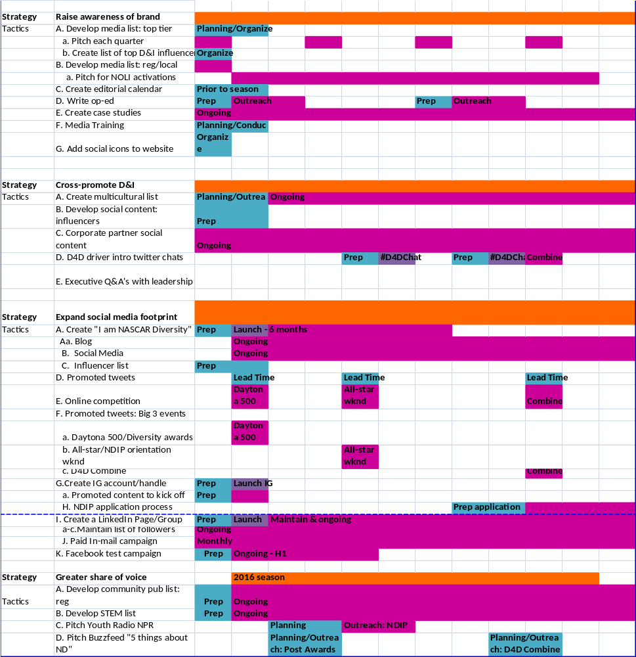
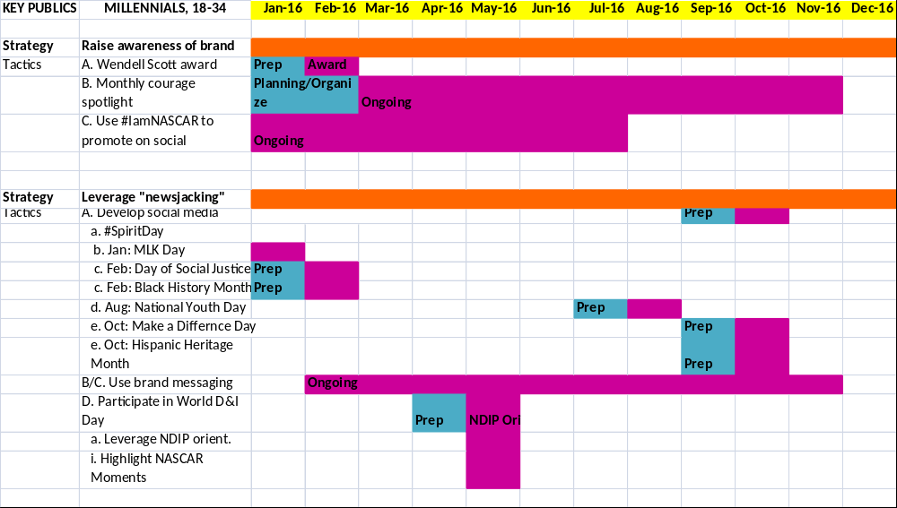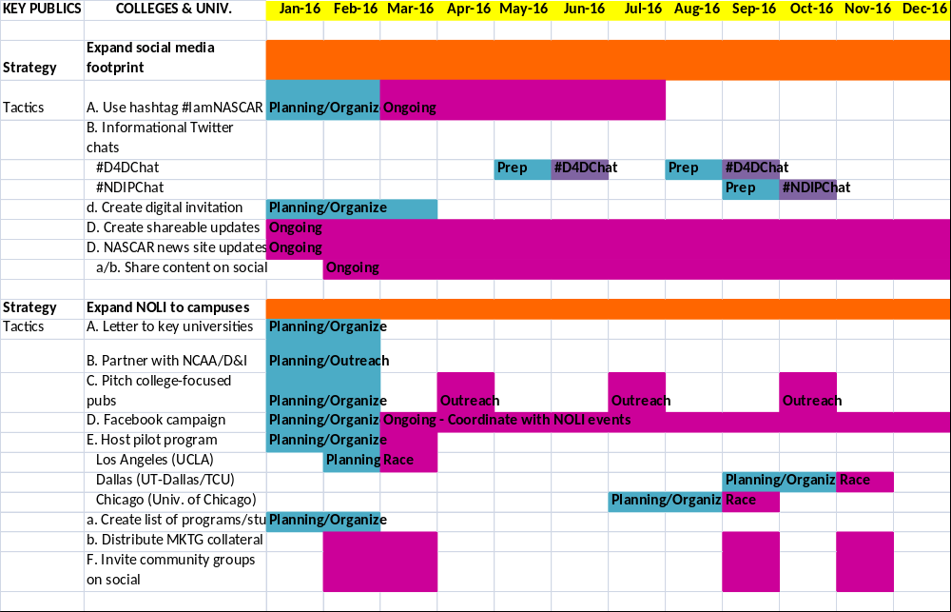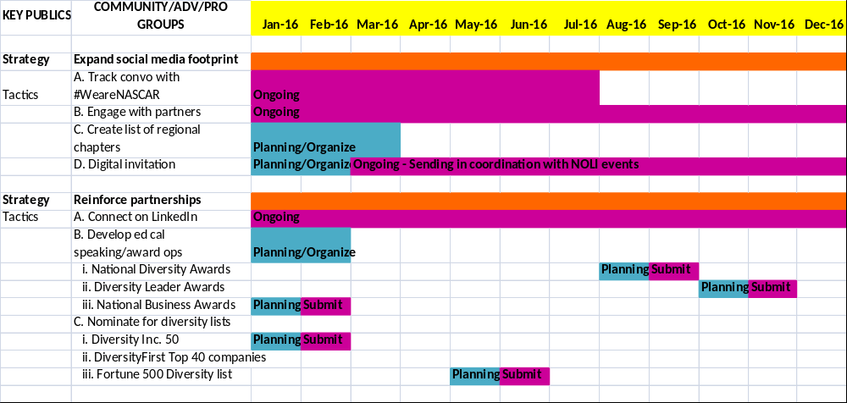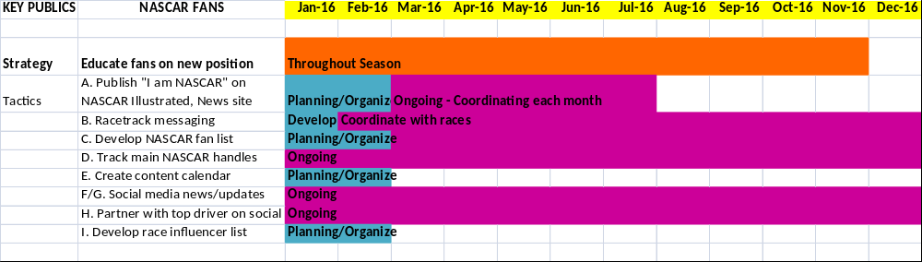

The following section includes a comprehensive budget of the intended strategies and tactics. In order to successfully implement this strategic communications plan, it is recommended to find a dedicated communications professional to assist in the execution of proposed tactics, as 30-40 hours per week are needed to complete tasks. Additionally, this plan projects a total cost of $126,136.88-140,061.88: this includes cost of an additional employee, production, development and event costs in relation to suggested tactics.
BUDGET
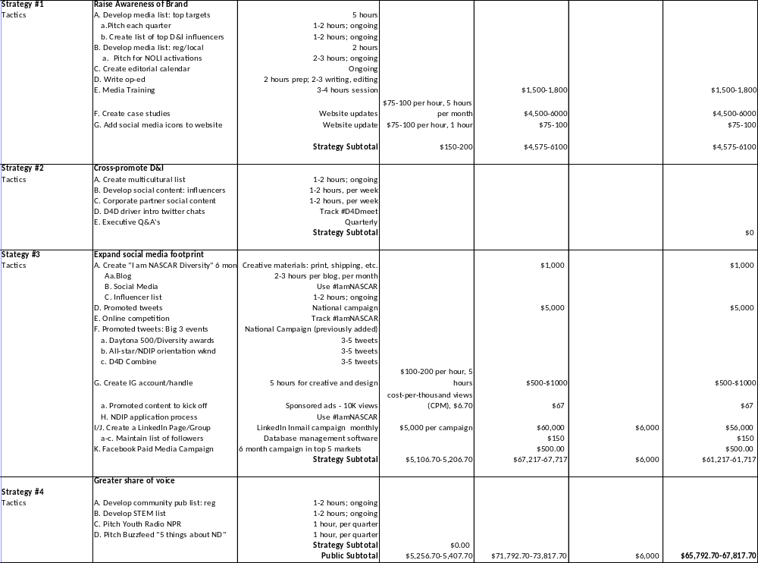
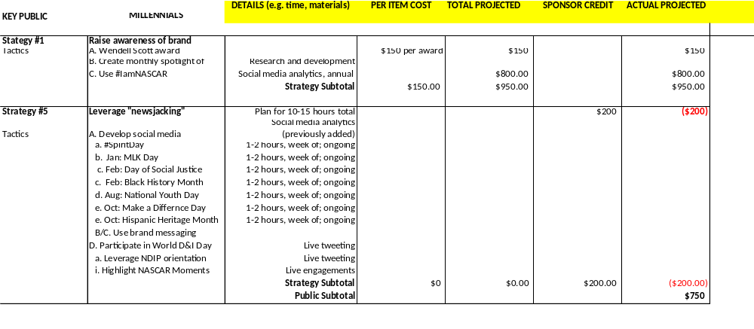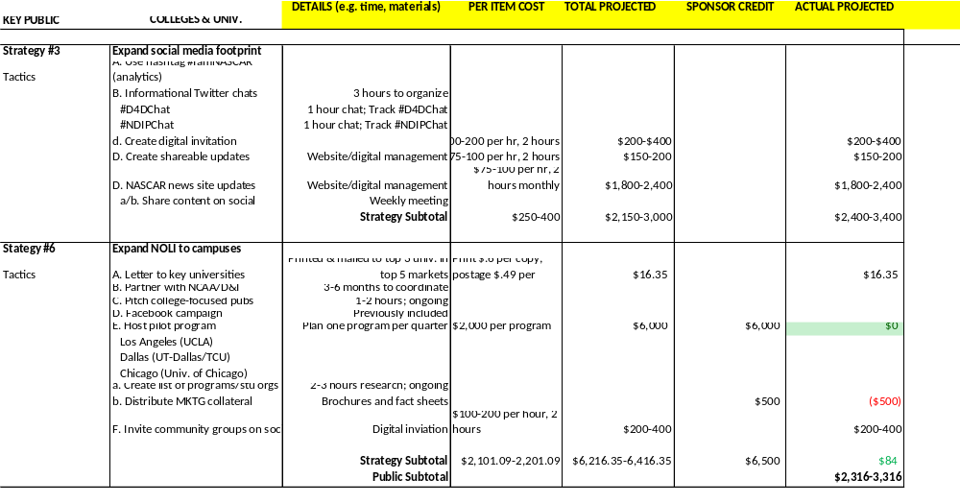
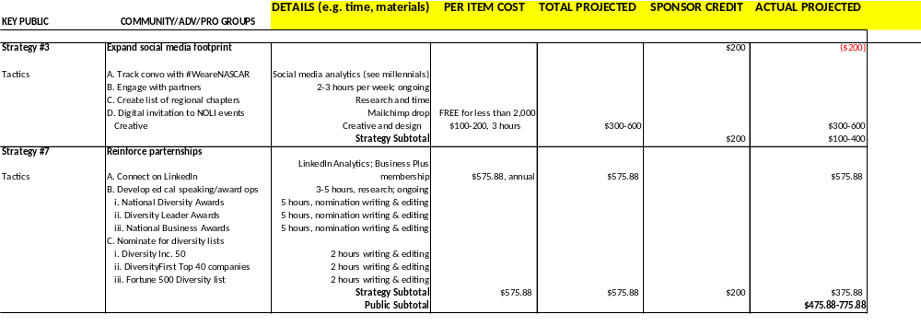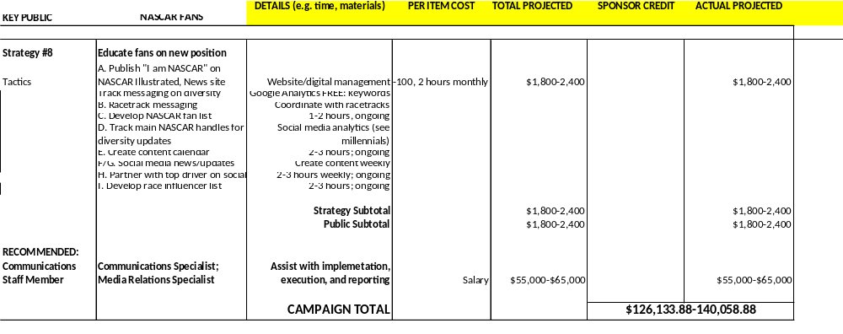

EVALUATION
Evaluation
This section will provide suggestions for initiating a measurement process and how to measure the effectiveness of key strategies and tactics to reach our goal and objectives. The main key performance indicators (KPIs) of this plan include:
- Monitor website traffic, click-through rates
- Track social media engagement
- Monitor participation on digital platforms
- Measure total campaign engagements
- Measure awareness through polling & survey

OBJECTIVE 1
Criteria
Increase the number of participants in NOLI by two additional community groups per quarter and increase the number of applicants in NDIP by 50, by the end of 2016 season
Tools
- To set a benchmark, NASCAR Diversity should use the participation numbers from the previous season to set measurement goals.
- To measure participation rates, using an event tool such as Mailchimp to analyze and track the number of participants that received, opened, and accepted invitations. Mailchimp tracks invitees and provides a database to monitor activity.
- Additionally, LinkedIn analytics, after a NOLI event, can provide information on the increase in the number of followers, requests to connect, and viewers of the NASCAR Diversity profile; this will indicate the number of participants’ for each event, enable management of new relationships and the increase in engagement, post event.
- For NDIP, compare the number of applicants from the previous season.
- Through the application system, tracking the number applications received will indicate if the goal was reached.
- Additionally, monitoring website click-through rates of the application page and application process will highlight engagement as well. Cross-referencing key social posts about the NDIP program will assist in better timing of posts and driving traffic toward the application.
- It is recommended that each program provide an opinion poll, post interaction, asking about best practices, challenges and overall experience when working with NASCAR Diversity.

OBJECTIVE 2
Criteria
Build awareness of NASCAR Diversity on and off the track by achieving one to two top-tier print media placements per quarter, by the end of 2016 season
Tools
- To start, use measurement of coverage from previous season and breakdown according to program. NASCAR Diversity receives the most coverage from the D4D program; therefore it is important to set this benchmark for other programs for subsequent years.
- In measuring brand awareness, a communications audit and media analysis for mentions or articles discussing new messaging, diversity programs or NASCAR Diversity helps evaluate reach, especially in target lists: top tier print media list, key activation markets media list, college and universities media list, local and regional media list, community list, and non-sports list.
- Measuring click-through rates of NASCARDiversity.com in Google analytics when secured interviews are published will help monitor an increase in traffic, as well as monitoring shared links to articles will measure engagement.
- It is also important to track the sharing of coverage from the original domain to social media platforms such as LinkedIn and Twitter, which is located on the publication site.
- Also, tracking the number of increased coverage during the 2016 season, in an excel spreadsheet, will be key to measure the improvement from the 2015 season. This will help set a benchmark of capabilities and improvements for subsequent years.
- Similarly, at the start of the 2016 season and at the end, a competitive and market analysis to benchmark other sports leagues in the diversity and inclusion space will measure success of our efforts.
- Monitor SEO influx as the communications plan is implemented every quarter.
- After benchmarks have been set for subsequent years, it is recommend that NASCAR Diversity consider being evaluated by Dr. Lapchick and the TIDES report card program, to gain an efficient assessment of the diversity programs and success.

OBJECTIVE 3
Criteria
Strengthen relationships with current corporate and community partners on social platforms by reaching 250,000 followers per quarter, by the end of 2016 season
Tools
- To start the evaluation of this objective, it is important to have the year-over-year results of the Twitter handle. LinkedIn and Instagram are new channels; therefore this is the first year of measurement.
- On LinkedIn and Twitter, track the conversations that mention or include corporate partners and measure their engagement (shares or likes) compared to other shared content. NASCAR Diversity can monitor these conversations immediately through tracking scheduled content posted weekly. This measurement over the course of the season will continually help shape the content to reach the overall objective.
- Using LinkedIn analytics for business, this information can provide results per posting and evaluate the performance of the company page. LinkedIn offers data about the effectiveness of the page's status updates, engagement, and reach, as well as information about the page's followers -- demographics, where they came from, how NASCAR Diversity’s following has grown over time, how your data compares to other companies, etc.
- Additionally, LinkedIn InMail will provide analytics on target audience and results of placement, engagement and increase in followers of page. It is important to do a cross-analysis of lead generations of potential partners from targeted outreach through InMail.
- To get the most out of LinkedIn for lead generation, promote and share links to NASCAR Diversity blog posts and landing pages in your company status updates, where appropriate in LinkedIn Groups, on company showcase pages, and in calls-to-action placed in posts published via LinkedIn's publishing platform.
- Then, track website traffic and measure the reach of content to other social platforms to reach the 250,000 followers quarterly.
- Using Google Analytics, a media analysis of keywords “Toyota” and “Chevrolet” along with “NASCAR Diversity” will help monitor conversations where both are mentioned.
- Through Twitter analytics, track the number of times community partners engage with scheduled content (e.g. retweet, favorite, click-through). From interactions with community partners, corporate partners, influencers and more throughout Twitter, Instagram, and LinkedIn, and calculating the reach of the followers of your followers (social media analytics), this objective can be obtained.
- Overall, tracking inquiries throughout the 2016 season will be very important. NASCAR Diversity has an email address (diversity@nascar.com) that is posted on their website and it’s important to track this as campaigns are launched to drive traffic to their website. Additionally, if NASCAR Diversity wins one of the planned awards submitted, monitoring engagement on LinkedIn with potential partners will be essential.

OBJECTIVE 4
Criteria
Expand awareness of NASCAR Diversity on at least two NASCAR-owned media channels by the end of 2016 season
Tools
- To start, it is important to get the 2015 season analysis of NASCAR Diversity mentions and content posted on NASCAR-owned media channels including: social media (Instagram, Twitter) and digital (NASCAR.com, NASCARDiversity.com).
- Each quarter of the 2016 season, conduct a content analysis of NASCAR Diversity news and updates on the two most popular channels: NASCAR.com news site and @NASCAR Twitter handle.
- By tracking click-through rates of the “I am NASCAR” blog post series and tracking reach through shares of the article, each quarter NASCAR Diversity can gauge the increase in diversity updates on NASCAR-owned media; as well as website engagement through Google Analytics.
- It is important to use the social media analytics software (e.g. Nuvi, Topsy) to monitor and track NASCAR’s owned social channels to gauge cross-promotional efforts and examine how well received diversity updates are on main NASCAR media.
- Through social media analytics, software (mentioned above) and social platforms analytics tools such as Twitter analytics and LinkedIn analytics, NASCAR Diversity should conduct an analysis and report tracking of the #IamNASCAR campaign on NASCAR-owned channels.
- Analyze how fans are using the hashtag, the sentiment in which their using it (e.g. positive, neutral, negative) and how it can be used in a more effective way, to have non-diversity community fans more engaged with the series.
- NASCAR Diversity should consider using Forbes’ Zogby polling to request demographic data on NASCAR fans at the end of each season. With the messaging refresh, this will help gauge if the new messaging is reaching existing and new NASCAR fan audiences.

OBJECTIVE 5
Criteria
Enhance social presence by increasing Twitter following by 2,500 members by the end of 2016 season and establish additional social channels
Tools
- The current twitter following is nearly 5,300. The goal by the end of the 2016 season is to have 7,800, by November 2016. This is an increase of 208 members per month.
- Social media analysis and tracking of the following hashtags are important: #IamNASCAR, #D4DChat, #NDIPChat, and #D4DIntro.
- Twitter analytics tracks the increase in the number of followers, profile visits, impressions, hashtag clicks and mentions. Additionally, they provide a follower demographic breakdown that will help target more influencers that align with the NASCAR Diversity brand and what messages are better received by the Twitter community.
- Additionally, Twitter analytics will provide information on the promoted tweets during the three big events: Daytona 500, All-star weekend, and the D4D Combine. Twitter will also provide recommendations on previously used content, to repurpose in a promoted tweet due to high levels of engagement.
- Any coverage secured should be monitored through analytics tools to track reshares to other social sites. Also, track press releases by monitoring the use of @NASCARDiversity handle when published on news sites.
- It is important to monitor and track cross-promotional diversity content posted on NASCAR-owned media that drives traffic to NASCARDiversity.com and social media channels.
- With each Twitter follower, send automatic direct message with short survey and track results.
- Finally, the social media analytics tool to measure hashtags and conversations will synthesize engagement and provide information on the sentiment of social media content. This will help establish a benchmark for subsequent years.

Conclusion
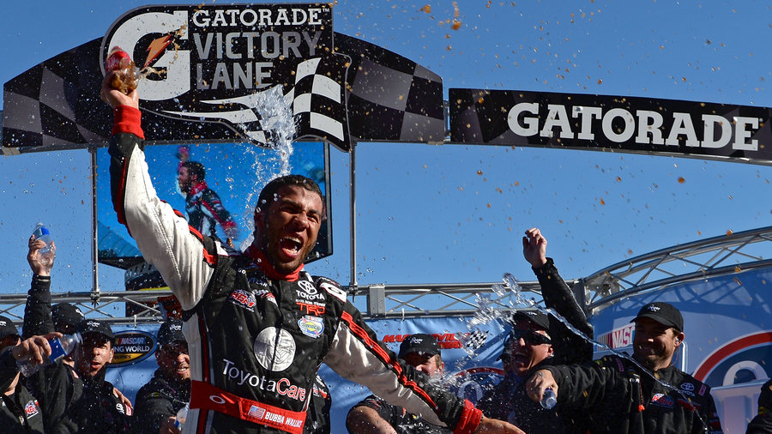
Diversity is one thing that we all have in common. NASCAR Diversity is building a pipeline to help their organization remain one of the best professional sports in the country. They are investing in people and processes that will enable growth and sustainability in the future. This 2015 media relations and strategic communications plan provides helpful insights and tactical approaches that NASCAR Diversity can implement immediately to build a dedicated communications platform and see sustainable results. By taking a definitive stance through targeted messaging, establishing key relationships, and strategic outreach, they will achieve a stronger foothold in the diversity and inclusion marketplace, ultimately gaining a higher level of awareness and using their platform to build a sense of community beyond the racetrack.

APPENDIX
Creative Materials

Letter to Stakeholders

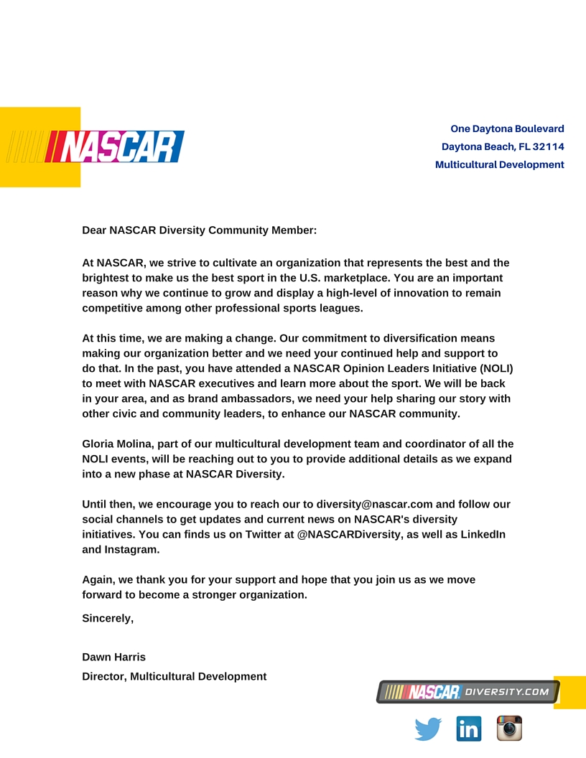

Digital Invitation

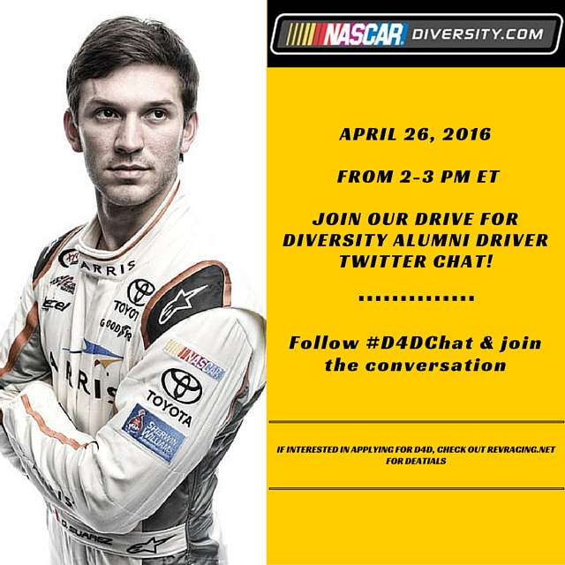

Digital Attachment for Social Media

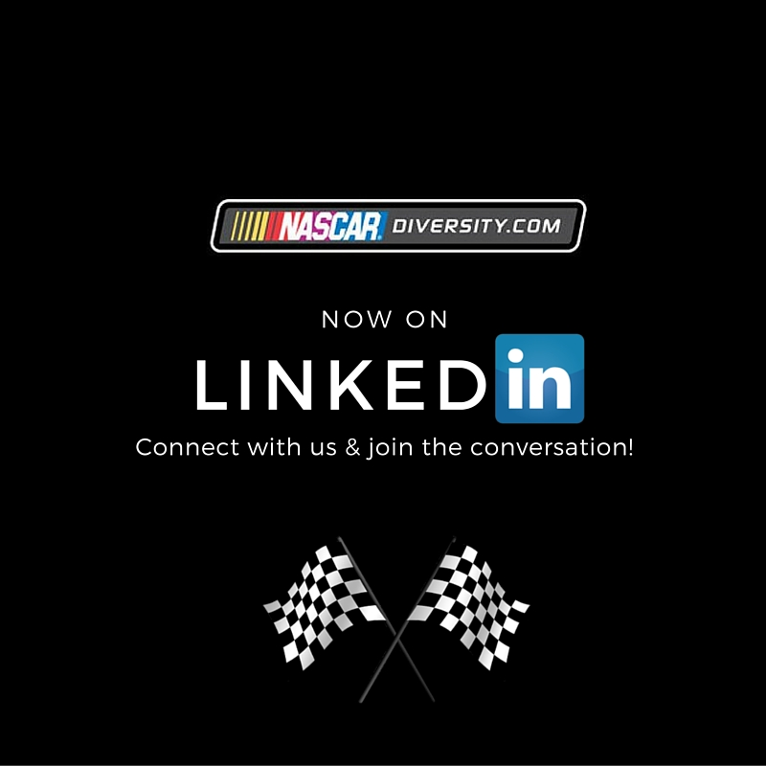

Potential Tweet

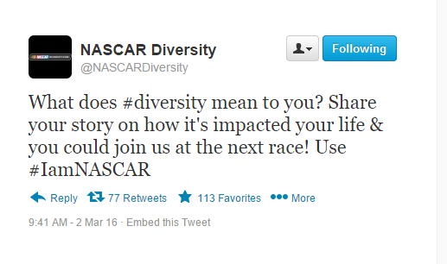
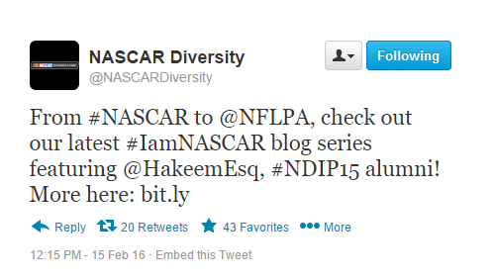
Top Multicultural Publications – Media List

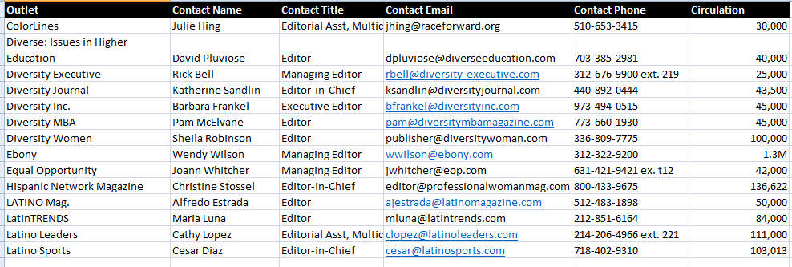

NASCAR Diversity 2016 Editorial Calendar and Planner

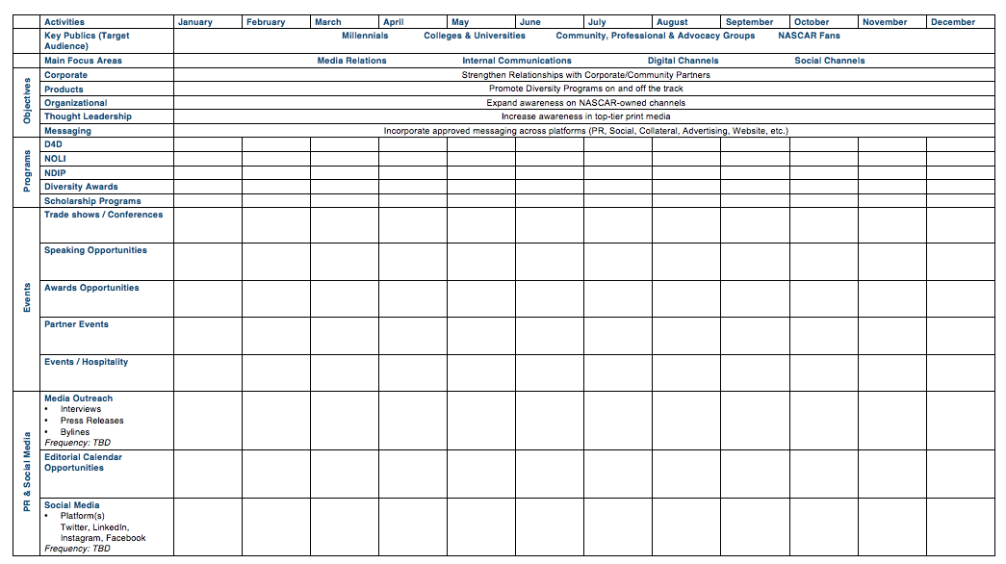
I am NASCAR Blog Title

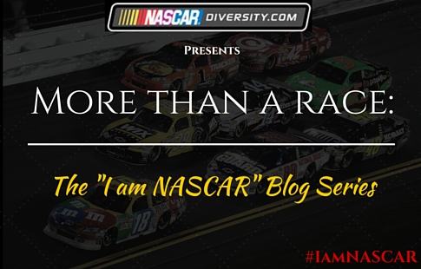

Social Media Best Practices: Instagram Tip Sheet


- Why should you be on Instagram

- The fastest growing social media platform
- More active users than Twitter
- It’s not just for the “kids”
- Best engagement rates on social media
- Community development

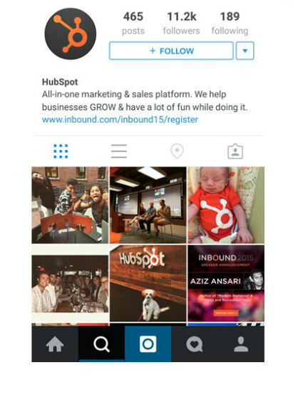
- Setting up an account for success

Profile: 5 key areas in your bio
- Profile Photo
- Name & Username (cant search by anything else but these two keywords, be more specific in the names
- Bio Description
- URL
- Public Profile

- Promoting business on Instagram

Types of content to share
- Products or services
- Offers and promotions
- Behind-the-scenes (shows personality, personable, people what to know more that what they typically see)
- Tips or tutorials
- Greetings or messages (motivational messages or videos; things going on in the community)
- Contests or giveaways
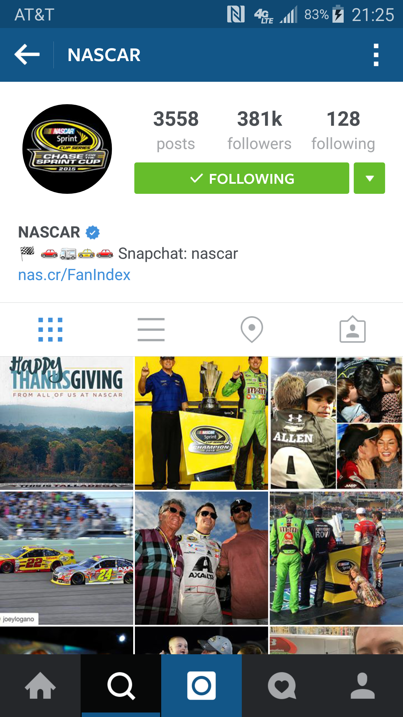
- Instagram exclusive content (don’t post content that’s on twitter or FB; why would people follow you on IG if you post it other places)

Use organic or native style images
- High resolution
- Unique perspectives
- Evoke emotions

Create videos (get twice the engagement of photos)
- Video is only 15 seconds
- Pick a great cover photo for the feed
- Create fresh new Instagram exclusive videos
- Repurpose existing video content

Creating quality captions
- be descriptive; tell a short story
- not too short, not too long (a paragraph, within the screen)
- take the photo/video “story” that much further

- Connecting with your audience

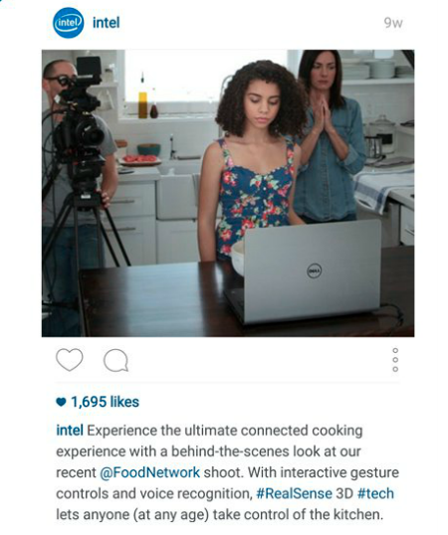
Connect with Branded Content
- Connect with your audience using branded content
- Relevant to your brand
- Consistent
- Recognizable

Connect by humanizing
- Connect with your audience by humanizing your brand
- Showcase your employees, community, initiatives, work with partners

Connect with your story
- Connect with your audience by telling them your story
- #TBT

- The use of a hashtag

Implementing a hashtag strategy
- Significantly increase the reach of your posts
- Help you target audience find you
- Create a custom hashtag gallery around your content

How to use a hashtag
- Use RELEVANT hashtag for the post
- Use industry related hashtags
- An average of 5-10 hashtags per post
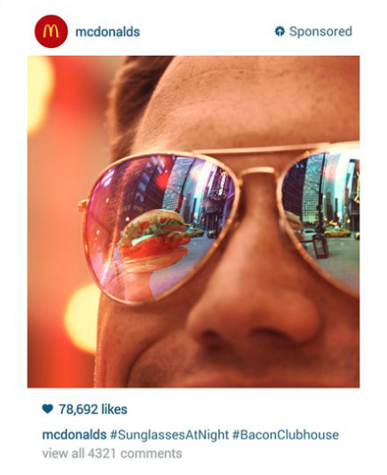
- Combine popular, moderately popular, less popular, and custom hashtags (content lasts long using certain hashtags or more specific if its customized)
- Don’t hashjack
- Captions vs. comments (hashtag in captions as well)

- Instagram Ads

- No longer just for big brands
- Ad budgets will be much more affordable
- Operate through Facebook ads manager

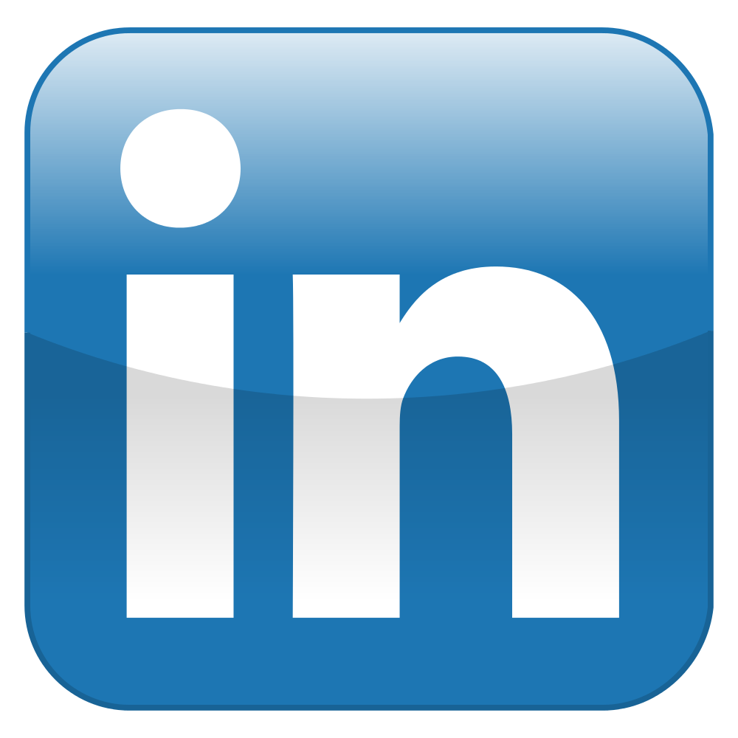
Social Media Best Practices: LinkedIn for Business Tip Sheet

- Optimize your LinkedIn Company Page.
The design of LinkedIn Company Pages has changed a lot over the years. Make sure yours is set up correctly and optimized for the latest layout, featuring a compelling and high-quality banner image
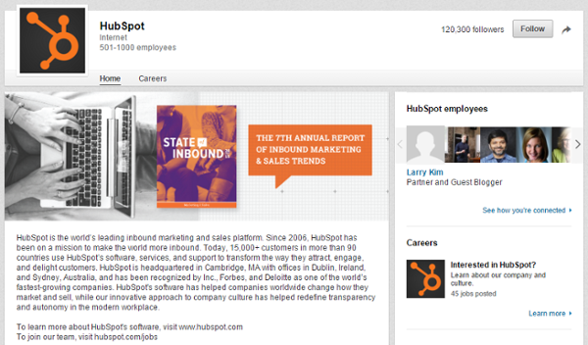

Keep in mind that as of April 2014, LinkedIn no longer supports the Products & Services tab on Company Pages. This means you may want to set up and take advantage of LinkedIn's Showcase Pages instead.
- Create targeted LinkedIn Showcase Pages.
LinkedIn Showcase Pages are niche pages that branch off your main Company Page. Think of them as extensions of your main Company Page that allow you to promote specific products or cater to your individual marketing personas, providing a more personalized experience for your Company Page visitors. LinkedIn users can also follow specific Showcase Pages without having to follow a company's main page or its other Showcase Pages, allowing your business to tailor the page closely to the audience specific to the page. LinkedIn allows you to create up to 10 Showcase Pages per each parent Company Page
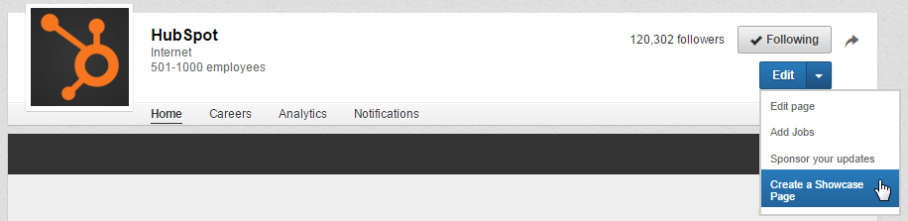
- Post Company Status Updates (and target them!).
Make the most of your LinkedIn Company Page by publishing Company Status Updates for all your page followers to see. This will give LinkedIn users even more reason to follow your Company Page, growing your LinkedIn reach.
Instead of using Company Status Updates, step it up a notch and leverage the power of segmentation with LinkedIn's targeting options, which enable you to target your status updates to specific users. As long as the target audience consists of at least 100 users, Company Page administrators can target their updates using criteria like company size, industry, job function, seniority, geography, language, or by including/excluding company employees. These targeted updates will appear on the Company/Showcase Page itself for those users as well as in the users' Network Updates feed on their LinkedIn homepage.
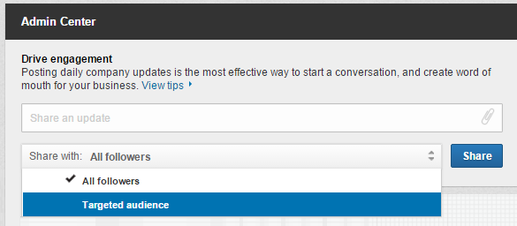
- Use LinkedIn Pulse to keep track of industry news.
Pulse is an awesome section of LinkedIn where you can discover popular articles and trending content tailored to your interests. You can find it under Interests in LinkedIn's top navigation.
Browse Top Posts to monitor the most popular content on LinkedIn Pulse, or click the Discover more link found via the hamburger menu to find and follow specific influencer contributors, publishers, or topic-related channels to stay on top of news and stories in your industry. You can also sign up for daily or weekly email summary notifications of Pulse news (found in the Updates and news section of your Email frequency settings), or instant notifications when influencers you're following post something new.
- Check out LinkedIn's Content Marketing Score & Trending Content resources.
If you're a LinkedIn Business Solutions customer, you can learn how impactful your organic and paid LinkedIn content is with the Content Marketing Score and Trending Content resources. Your Content Marketing Score measures user engagement with your Sponsored Updates, Company Pages, LinkedIn Groups, employee updates, and Influencer posts (when applicable). It then provides recommendations for how you can improve your score, and thus the effectiveness of your LinkedIn content.
You also can get a sense of which types of content are most popular on LinkedIn in your industry with LinkedIn's Trending Content resource. It highlights the most popular content being shared on LinkedIn for various audiences and topic segments. Monitor this to understand what content your company should be creating and sharing on LinkedIn to generate the most engagement.
- Use LinkedIn to generate leads.
To get the most out of LinkedIn for lead generation, promote and share links to your blog posts and landing pages in your Company Status Updates, where appropriate in LinkedIn Groups, on your Showcase Pages, and in calls-to-action placed in posts you publish via LinkedIn's publishing platform.
- Experiment with LinkedIn Ads and Sponsored Updates.
If you're looking to complement your organic LinkedIn marketing efforts with some paid advertising, LinkedIn Ads are a smart choice. One of the biggest benefits of LinkedIn advertising is the targeting options. LinkedIn’s PPC ads let you target specific job titles, job functions, industries, or company size, to name a few.
- Create your own industry LinkedIn Group, and join other relevant groups.
Create a group based on a relevant industry-related topic, and become a LinkedIn Group administrator. You can then use this group to establish yourself as a thought leader in your industry, grow a community of advocates, generate new marketing content ideas, and even generate new leads. You should also consider joining (and getting executives from your business to join) other relevant groups and participating in discussions to exhibit thought leadership in your industry.
- Email your LinkedIn Group.
One of the perks of managing a LinkedIn Group is the fact that you can literally email the members of your group -- up to once per week. These emails take the form of LinkedIn Announcements, which are messages sent directly to the email inboxes of group members (if they've enabled messages from groups in their settings). This is a prime opportunity for generating leads from LinkedIn, particularly if you've built up a robust group of users.
- Experiment with publishing content on Pulse (LinkedIn's publishing platform).
You no longer have to be a LinkedIn Influencer to publish new articles to LinkedIn Pulse. Publishing is available to all users. Experiment with how this feature can support your marketing goals by creating content for the platform and promoting it via your Company Page. For example, you could experiment with syndicating content from your business blog to LinkedIn Pulse and using it to promote subscription to your full blog.
Use the main navigation to navigate to Pulse:
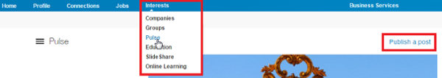
Or publish directly via your LinkedIn homepage:
- Recruit new talent via LinkedIn Careers.
You can use the Careers section of your Company Page to promote your available job openings. The look and feel of your Careers page depends on what information and images you choose to include, such as a list of jobs, people at your company, a summary section for your careers, what employees are saying about working at your company, and recent updates. Furthermore, if you're actively recruiting candidates with specific skills and expertise, don't forget about LinkedIn's Advanced Search feature.
- Add the Company Follow and LinkedIn share buttons to your website/content.
Promote your company's LinkedIn presence and help grow the reach of your Company Page by adding the Company Follow button to your website. Also consider adding the LinkedIn Share button to your various content assets like blog posts, emails, and landing pages to extend the reach of your content to LinkedIn users.
- Analyze your LinkedIn marketing performance with the Analytics tab on your Company Page.
Use the Analytics tab for Company Pages to evaluate the performance of your Company Page. This tab offers data about the effectiveness of your page's status updates, engagement, and reach, as well as information about your page's followers -- demographics, where they came from, how your following has grown over time, how your data compares to other companies, etc.

SWOT Analysis

Primary Research and Interview

*This survey was conducted to gauge the public's interest and support of diversity in sports, more specifically the motorsports industry. Questions 1 thru 5 were background questions, resulting in 71 percent being female, 52 percent being between the age of 25-34, and the majority of respondents being African-American and Caucasian-American. Questions 6-7 resulted in 90 percent of respondents admitting to being sports fans and ranked the NFL, NBA, and MLB as their top sports to support. There were a total of 42 participants.

8. Does a leagues support of social justice (discrimination, sexism, same-sex marriage, etc.) increase your engagement or support?
Answer Options |  | Response Percent | Response Count
Absolutely |  | 26.2% | 11
Yes, but not a requirement |  | 21.4% | 9
No, but I would like to see more leagues support these initiatives |  | 21.4% | 9
No, I'm just a sports fan |  | 31.0% | 13
I don't know much about professional sports |  | 0.0% | 0
answered question |  |  | 42
skipped question |  |  | 0
10. Which professional sports leagues do you feel have actively engaged in increasing diversity, internally (workforce, etc.) and externally (community programs, etc.)? (Please select all that apply.)
Answer Options |  | Response Percent | Response Count
National Football League (NFL) |  | 68.3% | 28
National Basketball Association (NBA) |  | 70.7% | 29
Major League Baseball (MLB) |  | 19.5% | 8
National Hockey League (NHL) |  | 14.6% | 6
Major League Soccer (MLS) |  | 14.6% | 6
National Association of Stock Car Auto Racing (NASCAR) |  | 17.1% | 7
Women's National Basketball Association (WNBA) |  | 48.8% | 20
None |  | 9.8% | 4
Other (please specify) |  |  | 1
answered question |  |  | 41
skipped question |  |  | 1
11. What role do you think professional sports play in social justice issues, such as race relations and diversity, if at all? Please provide brief response.
Answer Options |  | Response Count
 |  | 29
answered question |  | 29
skipped question |  | 13

Number | Response Text |  | Categories
1 | They should play more of a role than they do.
2 | I think they play a big role because a lot of these professional athletes are role models to so many people that their thoughts may shape others opinions on social issues.
3 | Professional sports are looked upon as icons or leaders for the youth. So they basically set the bar for what the country is going to become. For example, Jackie Robinson becoming part of the MLB some could say that helped start the Civil Rights movement.
4 | None, it is nice to see when they do make an effort though (breast cancer awareness month, different ethnic group, supporting and praising those who have come out of the closet)
5 | Sports figures are role models whether they like it or not. Their behavior is seen by others and the way they act is modeled by those that look up to them. Having athletes that are inclusive of race, gender, sexual orientation etc will cause others to likely follow in their footsteps.
6 | They can play a big part, but most don't
7 | They play a huge role, fans are influenced by their sports heroes
8 | Role models
9 | I feel alot especially with race car driving
10 | Major influence on society as a whole. They impact the entire nation.
11 | Can use their visibility to raise awareness and support
12 | It should play a huge role as we have young to old individuals actively watching
13 | Hard to say. Sports should set good examples
14 | While the sport itself is the main business initiative, leagues have a social responsibility not to support, enable or promote behavior, actions that are counterproductive to improving social justice issues such as race relations and diversity. I don't think they necessarily need to be active in these conversations, but when it involves a particular league's sport, athlete or employee the league should certainly make actions and responses that promote diversity. Also think the best role any organization, sports or non-sports, can play in diversity is diversity of all sorts (gender, race, age, etc.) in all levels of personnel.
15 | Athletes, as idols, have a responsibility to be positive role models, especially when it comes to acceptance of marginalized people.
16 | Influential voice, marketing messages
17 | I think diverse teams can help the "everyman" become familiar with other races/cultures in a non-threatening manner.
18 | Pro sports have an impact on race relations similar to music and mathematics, sports have a universal appeal (and language) that is being appreciated by all peoples worldwide. There is more work to do to reach higher inclusiveness. Many professional and college sports venue are on the right path to achieve even better inclusiveness.
19 | Everyone should have equal opportunities based on talent. However, we should not be looking to sports to guide this dialogue. If more minorities’ played hockey, the NHL would be more diverse.
20 | Professional sports serve as an example of diversity in the role of bringing people together from different background and ethnicities, together for a common goal!
21 | It's a model of togetherness.
22 | They need to lead the way. Be a good influence and mentor in these areas. Kids (and adults) look up to them.
23 | Some sports do but not all that I know of. I wish the media would expose us more to it if they do or don't.
24 | Not much.
25 | I think sports play a major role in social justice, race, and diversity. Team work, the community, and making any sport international teaches awareness and breaks down cultural barriers for one common goal together. Win.
26 | Sports can be a common dominator between different races and cultures. No matter what color you might be, you can root for the same team
27 | I think professional athletes sometimes make issues worse
28 | A huge role because, many people of all ages watch different types of sports. So if those people see that the sports world is taking a stand then those people watching it will want to join and support also.
29 | It is a sponge for us. We soak up what we see and hear.
13. Do you think the motorsports industry does a good job of presenting themselves as an open and inclusive industry?
Answer Options |  |  |  | Response Percent |  | Response Count
Yes |  |  |  | 0.0% |  | 0
Yes, but it could be better |  |  |  | 4.9% |  | 2
No, but they are getting better |  |  |  | 24.4% |  | 10
No, not at all |  |  |  | 41.5% |  | 17
I don’t patron their leagues |  |  |  | 29.3% |  | 12
answered question |  |  |  |  |  | 41
skipped question |  |  |  |  |  | 1
14. If 'No' to the previous question, do any of the following apply: (Please select all that apply.)
Answer Options |  |  |  | Response Percent |  | Response Count
Lack of diverse athletes |  |  |  | 56.4% |  | 22
Lack of workforce diversity |  |  |  | 23.1% |  | 9
Lack of community engagement |  |  |  | 25.6% |  | 10
I rarely or never hear about their inclusion efforts in the news or media |  |  |  | 61.5% |  | 24
I don't like motorsports |  |  |  | 43.6% |  | 17
answered question |  |  |  |  |  | 39
skipped question |  |  |  |  |  | 3
15. Have you ever watched or attended a NASCAR race?
Answer Options |  |  |  | Response Percent |  | Response Count
Yes |  |  |  | 47.6% |  | 20
No |  |  |  | 45.2% |  | 19
No, but I would like to in the future |  |  |  | 7.1% |  | 3
answered question |  |  |  |  |  | 42
skipped question |  |  |  |  |  | 0
16. If no, do any of the following reasons apply to why you haven’t/won’t attend a race: (Please select all that apply.)
Answer Options |  |  |  | Response Percent |  | Response Count
I answered yes to the previous question |  |  |  | 24.2% |  | 8
Non-diverse sport |  |  |  | 15.2% |  | 5
Lack of inclusion |  |  |  | 12.1% |  | 4
Not an exciting sport |  |  |  | 48.5% |  | 16
Too Southern |  |  |  | 15.2% |  | 5
Too conservative |  |  |  | 15.2% |  | 5
Racetracks are not accessible/near by |  |  |  | 18.2% |  | 6
I’m not into cars |  |  |  | 27.3% |  | 9
Other (please specify) |  |  |  |  |  | 1
answered question |  |  |  |  |  | 33
skipped question |  |  |  |  |  | 9
17. Did you know NASCAR has several diversity initiatives aimed to increase awareness to people of color and women, on and off the track? (Including a paid internship program and community outreach initiatives)
Answer Options |  |  |  | Response Percent |  | Response Count
Yes |  |  |  | 14.3% |  | 6
No, but I'm interested in learning more |  |  |  | 35.7% |  | 15
I had no idea |  |  |  | 50.0% |  | 21
answered question |  |  |  |  |  | 42
skipped question |  |  |  |  |  | 0
20. Have you heard of any of the following NASCAR Drive for Diversity participants, who are current drivers in NASCAR's top circuits: (please select all that apply.):
Answer Options |  |  |  | Response Percent |  | Response Count
Darrell “Bubba” Wallace |  |  |  | 11.9% |  | 5
Kyle Larson |  |  |  | 7.1% |  | 3
Aric Almirola |  |  |  | 0.0% |  | 0
Ryan Gifford |  |  |  | 4.8% |  | 2
Daniel Suarez |  |  |  | 4.8% |  | 2
None of these drivers |  |  |  | 78.6% |  | 33
answered question |  |  |  |  |  | 42
skipped question |  |  |  |  |  | 0
21. How do you think NASCAR can better engage with diverse demographics? (Please select all that apply.)
Answer Options |  |  |  | Response Percent |  | Response Count
More diversity programs |  |  |  | 34.2% |  | 13
Better media coverage (articles, social media, broadcast, etc.) |  |  |  | 73.7% |  | 28
Partner with other diversity and inclusion initiatives |  |  |  | 63.2% |  | 24
Work with other professional sports teams to increase diversity |  |  |  | 44.7% |  | 17
Increase community relations near racetracks |  |  |  | 42.1% |  | 16
Better onsite advertisement at the racetrack |  |  |  | 13.2% |  | 5
Other (please specify) |  |  |  |  |  | 2
answered question |  |  |  |  |  | 38
skipped question |  |  |  |  |  | 4

Number |  | Other (please specify) |  |  | Categories
1 |  | Community initiatives including campus events and maybe even affiliations w/ auto shows
2 |  | NASCAR could increase efforts with coverage in middle school and high school venues, and other venues that promote minority participation and awareness.
22. Which social media platforms do you use most often? (Please select all that apply.)
Answer Options |  |  | Response Percent | Response Count
Facebook |  |  | 90.5% | 38
Twitter |  |  | 19.0% | 8
YouTube |  |  | 33.3% | 14
Instagram |  |  | 45.2% | 19
Snapchat |  |  | 16.7% | 7
Periscope/Meerkat |  |  | 7.1% | 3
I'm not on social media often |  |  | 7.1% | 3
answered question |  |  |  | 42
skipped question |  |  |  | 0
23. If you were to watch a NASCAR race, what platform would you most likely use to follow their event? (Please select all that apply.)
Answer Options |  |  | Response Percent | Response Count
Facebook |  |  | 68.3% | 28
Twitter |  |  | 19.5% | 8
YouTube |  |  | 24.4% | 10
Instagram |  |  | 22.0% | 9
Snapchat |  |  | 12.2% | 5
Periscope/Meerkat |  |  | 2.4% | 1
I'm not on social media often |  |  | 12.2% | 5
answered question |  |  |  | 41
skipped question |  |  |  | 1
24. How do you consume your favorite sports leagues? (Please select all that apply.)
Answer Options |  |  | Response Percent | Response Count
Television (Cable, etc.) |  |  | 95.2% | 40
Online streaming (Laptop, tablet, etc.) |  |  | 26.2% | 11
Phone apps (NFL mobile, NBA mobile, etc.) |  |  | 35.7% | 15
Social media (Twitter, Facebook, etc.) |  |  | 33.3% | 14
I'd rather watch live at a venue |  |  | 26.2% | 11
Other (please specify) |  |  |  | 0
answered question |  |  |  | 42
skipped question |  |  |  | 0

Interview with a D&I Representative from the United States Tennis Association

*The author reached out to several influencers of diversity and inclusion, in several organizations, including the NBA, MLB, NASCAR, USTA, NHL, Consumer Goods Industry, Technology, and others. The following interview questions were provided to each. These interviews were initiated to gain more insight info the diversity and inclusion space. A representative from the U.S. Tennis Association was so gracious to provide the responses below:

- As a leader in your organization on behalf of inclusion, what is the goal of your diversity programs?

At the USTA, diversity is one of the core values that supports our mission which is to promote and develop the growth of tennis. We recognize that given the changing demographics and the increasingly multicultural landscape of the U.S., we will be unable to fulfill the mission without a significant focus on diversity and inclusion.

- The industry standard cites a difference between inclusion and diversity. Do you see it this way? If not, why is this so?

Yes, there is a difference between the two. Diversity simply refers to the presence of persons reflecting a broad range of dimensions within an organization (gender, race, ethnicity, sexual orientation/identity, etc.) Inclusion is the proactive, intentional commitment to effectively leverage these diversity dimensions to ensure the organization’s success. For example, consider the analogy of baking. You may have all the ingredients for a cake, but if you don’t combine the ingredients according to the recipe, it will be impossible to bake a cake.

- In your opinion, does diversity lead to increased engagement (engagement meaning audiences are paying attention to your message and actively participating), from a consumer perspective?

Diversity and inclusion can promote increased engagement if an organization employs a holistic, strategic approach. At USTA, our commitment includes 6 pillars:

- Human Assets
A focus on the diversity & inclusion of our talent, including staff, volunteers, coaches, officials, etc.

- Image
Ensuring that all of our communication touch points convey tennis is a sport that includes everyone

- Supplier Diversity
A commitment to include diverse suppliers in all of our purchasing opportunities

- Section & Community Engagement
Ensuring that each of our 17 Sectional offices across the country are focused on inclusion in their grassroots, recreational outreach

- Strategic Partnerships
A focus on building relationships with key organizations and individuals to deepen our connection with diverse audiences

- Training & Development
A commitment to equipping our teams with cross-cultural dexterity through ongoing training and development initiatives

- What challenges do leagues face in regards to implementing programs to increase diversity and what challenges are there to maintain these programs?

The challenges faced in the sports industry are consistent with all organizations that are focused on diversity and inclusion. Chief of these is that any change effort is difficult to manage. One way that USTA addresses this challenge is that our D&I team serves as consulting resource to our internal departments. Our philosophy is to support these stakeholders in fulfilling their goals and objectives by offering diversity-related solutions. Diversity is therefore not positioned as an add-on responsibility, but rather as an element that can fuel broader organizational priorities.

Another challenge is that to sustain diversity initiatives, they must be championed at the top. To signal the critical importance of these efforts, diversity should be a central element of the chief executive’s platform. This conveys throughout the organization that diversity is a key priority. At USTA, D&I is part of the Executive Office and reports directly to the Chief Operating Officer.

- In your organization, what is the best way to create pathways of inclusion?

At USTA, a key inclusion strategy is our Business Resource Group effort. A Business Resource Group (BRG) is an organizationally-supported group of employees reflecting a specific dimension of diversity, drawn together by the characteristics or interests that the group holds in common. Members of the BRGs actively engage in communication and/or gather around a central unifying purpose, mission, background or activities. While each group is focused on a particular aspect of diversity, the BRGs are open to any team member who has an interest in learning about or supporting the mission of the group.

The activities of the BRGs support the USTAs competitive market advantage and are closely tied to the organization’s D&I strategy. Each BRG has senior leaders embedded within them as advisors. The advisors guide the groups, support their programming and assist them in tying their activities to mission-centered goals and objectives. The groups therefore provide unparalleled visibility and access to senior leaders. They also offer employees the opportunity to work on projects that offer skill-building in areas outside of their day-to-day jobs. The BRGs also provide valuable insights to inform the organization’s marketing and outreach efforts to audiences that reflect their respective dimensions of diversity.

There are 7 USTA BRGs:

- ACE Network (African American & Caribbean employees)
- Asian American
- Latino/Hispanic
- Millennials
- Partners (LGBT)
- Women’s
- Working Parents

- How do you gauge the success of a diversity program once implemented?

Diversity is really not a program with a start and end. Diversity requires a long-term commitment though the specific elements may continue to evolve across time. There is a danger in expecting year-over-year ROI for diversity efforts in that an organization may abandon its work prematurely. However, there are several markers of success that can be tracked:

- Increased tennis participation by diverse audiences
- Increased spend with diverse suppliers
- Increased representation by diverse talent
- Increased retention of diverse talent
- Increased diverse board participation

- On a scale of one through 10, one being not effective at all and 10 being extremely effective, how would you rank your diversity programs at your respective sport (or organization)?

I would rank USTAs diversity and inclusion initiative as an 8. We have many accomplishments to celebrate with our D&I effort, but there are still opportunities for us to continue to develop and grow.

- On a scale of one through 10, one being not effective at all and 10 being extremely effective, how would you rank the diversity and inclusion platform as a whole throughout the professional sports (or your) industry?

I would rate USTAs platform within the sports industry as a 10 given our holistic approach to inclusion.

References

Fallon, Nicole. 2015 June 19. Business News Daily. What is Corporate Social Responsibility? http://www.businessnewsdaily.com/4679-corporate-social-responsibility.html#sthash.oFpDechh.dpuf
Duffy, Neill. 2012 June 28. Triple Pundits. Leveraging Sports as a CSR & Sustainability Platform. http://www.triplepundit.com/2012/06/sports-csr-sustainability-americas-cup/
United States Tennis Association. Diversity and Inclusion definitions. www.usta.org
Rosenbaum, Eric. 2015 April 24. CNBC. The 10 Global Companies trying to lead on diversity: study. http://www.cnbc.com/2015/04/24/the-10-global-companies-trying-to-lead-on-diversity:-study.html
Primary research survey: Diversity in Professional Sports. https://www.surveymonkey.com/r/diversityinsports
Lapchick, Dr. Richard. The Institute of Diversity and Ethics in Sports. Racial and Gender Report Card. http://www.tidesport.org/racialgenderreportcard.html
The Official NASCAR website. www.nascar.com
Pertrillo, Nick. July 2015. IBIS World: Racing and Individual Sports in the US.
NASCAR. Official website of NASCAR. www.nascar.com
Smith, Chris. 2015 Feb 18. Forbes. How NASCAR Plans to Turn Its Survival Story into a Decade of Success. http://www.forbes.com/sites/chrissmith/2015/02/18/how-nascar-plans-to-turn-its-survival-story-into-a-decade-of-success/
NASCAR Diversity. Official website of NASCAR Diversity. www.nascardiversity.com
Bianchi, Jordan. 2015 September 10. SB Nation. NASCAR’s Confederate Flag Conundrum. http://www.sbnation.com/nascar/2015/9/10/9299515/nascar-confederate-flag-darlington-south-carolina
Bever, Lindsay & Justin Moyer. 2015 July 05. Washington Post. NASCAR faces ‘Southern Thunder’ as Confederate Flags fly at Daytona. https://www.washingtonpost.com/news/morning-mix/wp/2015/07/06/nascar-faces-rebellion-as-confederate-flags-fly-at-daytona/
Jessop, Alicia. 2015 October 15. The Huffington Post. NASCAR’s First Family Builds an Inclusion Mission on and off the Racetrack. http://www.huffingtonpost.com/alicia-jessop/post_10242_b_8304500.html
NASCAR Diversity Internship Program 2014. Lunch and Learn with Mike Helton.
Minority Youth Matters Movement. 2015 September 20. NASCAR: Protest over “diversity and inclusion practices” planned for Sunday. http://www.racer.com/nascar/item/121703-nascar-protest-over-diversity-and-inclusion-practices-planned-for-sunday
NASCAR Diversity. www.nascardiversity.com
NASCAR Diversity. www.NASCARdiversity.com
NBA Cares. The official website of NBA Cares. www.nbacares.com
NFL. The official site of the National Football League. www.nfl.com
MLB. The official site of Major League Baseball. www.mlb.com
NHL Diversity. The official website for NHL Diversity. http://www.nhl.com/nhlhq/community/diversity.html
Mintel. August 2015. Market Research: Marketing to Sports Fans – US.
Mintel. February 2015. Market Research: Marketing to Millennials – US.
Pew Research. 5 facts about Americans Students. http://www.pewresearch.org/fact-tank/2015/08/10/5-facts-about-americas-students/
Sports Business Research Network – Market Summary. Motorsports: NASCAR
Zogby, John. 2015 Aug 15. Forbes. The Dramatic Transformation of NASCAR America. http://www.forbes.com/sites/johnzogby/2015/08/16/the-dramatic-transformation-of-nascar-america/
Bever, Lindsay & Justin Moyer. 2015 July 05. Washington Post. NASCAR faces ‘Southern Thunder’ as Confederate Flags fly at Daytona. https://www.washingtonpost.com/news/morning-mix/wp/2015/07/06/nascar-faces-rebellion-as-confederate-flags-fly-at-daytona/
National Center for Education Statistics. www.nces.ed.gov/fastfacts/display.asp?id=372
Mintel. Marketing to College Students – U.S. July 2011.
McKenna, Farrell. February 2015. IBIS World: Civic, Social, and Youth Organizations Market Research.
NASCAR Diversity.
Vaughan, Pamela, 2015 Oct 29. Hubspot Blog. How to Use LinkedIn: 35 Tips for Professional Networking, Business & Marketing. http://blog.hubspot.com/blog/tabid/6307/bid/23454/The-Ultimate-Cheat-Sheet-for-Mastering-LinkedIn.aspx

